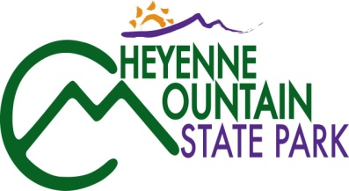
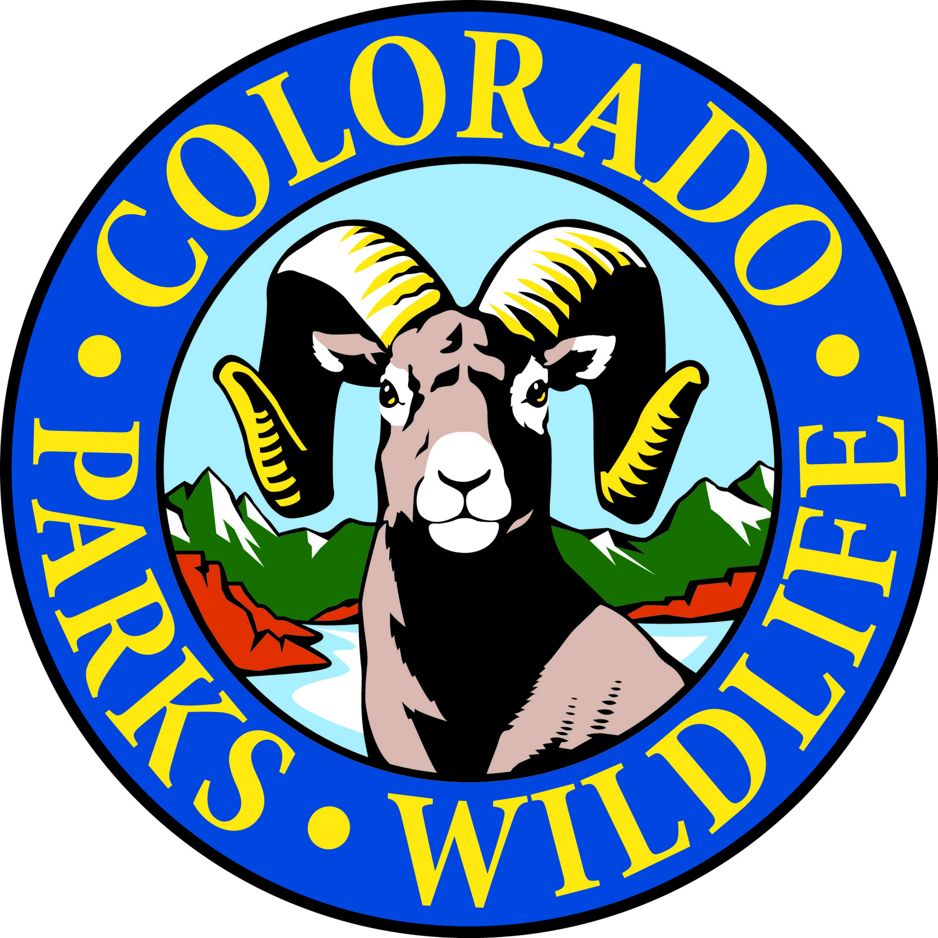

Cheyenne Mountain State Park is celebrating Colorado Day on Monday, August 7th!

COLORADO SPRINGS, Colo. –Cheyenne Mountain State Park is located south of Colorado Springs at 410 JL Ranch Heights Road. Take Nevada Avenue south, which becomes Colorado State Highway 115 to JL Ranch Heights Road opposite the Main Gate One entrance to Fort Carson. Turn to the west to the park entrance. Programs are free unless otherwise noted, but vehicles entering the park must have a $7 daily or $70 annual State Park pass. For more information, call 719-576-2016.

August Programs 2017

Saturday, August 5

Program: Archery
Time: 9:00 a.m. – 11:00 a.m.
Location: Cheyenne Mountain State Park Archery Range
Details: One on one instruction will help students learn how to shoot or polish up on skills you already have. All equipment is provided. Ages 8 and up. *Reservations required with a limited number of spaces available* State Park pass is required (Daily $7, Annual $70). You may purchase a park pass at the Archery Range with cash or check, or with a different form of payment at the Visitor Center or Entrance Station.
Information: 719-576-2016

Program: Archery Practice
Time: 11:00 a.m. – 12:00 p.m.
Location: Cheyenne Mountain State Park Archery Range
Details: For those who have completed our beginning archery class, we are offering a practice session to hone your skills. Equipment and instruction provided. Ages 8 and up. *Reservations required with a limited number of spaces available* State Park pass is required (Daily $7, Annual $70). You may purchase a park pass at the Archery Range with cash or check, or with a different form of payment at the Visitor Center or Entrance Station.
Information: 719-576-2016

Program: What’s Blooming Discovery Hike
Time: 1:00 p.m. – 2:30 p.m.
Location: Cheyenne Mountain State Park Limekiln Trailhead
Details: Discover what’s blooming around Cheyenne Mountain with the park naturalist on an easy, one mile or less trail hike. Identification books and magnifying glasses will be available for use on the hike. Recommended for ages 6 years and up. Closed-toe shoes required. Hiking shoes recommended. Reservations requested. State Park pass is required on all vehicles entering the park (Daily $7, Annual $70).
Information: 719-576-2016

Sunday, August 6

Program: Discovery Table-Western Rattle Snakes! (A.K.A. Prairie Rattler)
Time: 10:00 a.m. – 12:00 p.m.
Location: Cheyenne Mountain State Park Limekiln Trailhead
Details: The park naturalist will have a table at the trailhead with rattle snake items that you can view and/or touch to learn about this interesting venomous pit viper that calls Cheyenne Mountain State Park home. (No live snakes will be utilized during this learning experience). State Park pass is required on all vehicles entering the park (Daily $7, Annual $70).
Information: 719-576-2016

Monday, August 7

Program: Colorado Day Discovery Hike – Free Park Admission today only!
Time: 1:00 p.m. – 2:30 p.m.
Location: Cheyenne Mountain State Park Limekiln Trailhead
Details: Colorado turns 141 years old today, and we invite you to join us on our Colorado Day Discovery Hike! We will have interesting facts to share with you about Colorado, Colorado Parks and Wildlife, and your own state park, Cheyenne Mountain. Closed-toe shoes required. Hiking shoes recommended. Recommended for ages 7 and up. Closed-toe shoes required. Hiking shoes recommended. *No parks pass is required on Colorado Day, Monday, August 7th! Reservations requested. Hike will be limited*
Information: 719-576-2016

Program: Full Moon Hike—Sturgeon Moon – Free Park Admission today only!
Time: 7:30 p.m. – 9:00 p.m.
Location: Cheyenne Mountain State Park Camper Services
Details: August’s full moon is commonly known as the Sturgeon Moon for the fish found in the American Great Lakes. Other Indian tribes named it according to the crops that became ripe at this time of summer. Join the park naturalist on an easy, guided hike where we will end at the park’s amphitheater and watch the moon rise over the horizon (weather permitting). Recommended for ages 7 and up. Closed-toe shoes required. Hiking shoes recommended. *Reservations required with a limited number of spaces available. No parks pass is required on Colorado Day, Monday, August 7th!*
Information: 719-576-2016

Wednesday, August 9
Program: Wildflower Hike
Time: 9:00 a.m. – 11:00 a.m.
Location: Cheyenne Mountain State Park Visitor Center
Details: Wednesday Wildflower Walks begin again! This is a beautiful, easy guided nature walk with volunteer naturalist Lucy Bell that lasts about an hour and a half and focuses on all the wonderful wildflowers that can be found around the Park. Recommended for ages 7 and up. Closed-toe shoes required. Hiking shoes recommended.
Reservations requested. State Park pass is required on all vehicles entering the park (Daily $7, Annual $70).
Information: 719-576-2016

Thursday, August 10

Program: Moth Night
Time: 8:00 – 10:00 p.m.
Location: Cheyenne Mountain State Park Limekiln Trailhead
Details: Come join us on the new moon by tracking moths with insect experts from the Mile High Bug Club. Discover how amazing these nighttime insects can be. Fabric sheets and special lights will be used to attract moths for close inspection and identification. State Park pass is required on all vehicles entering the park (Daily $7, Annual $70).
Information: 719-576-2016

Friday, August 11

Program: Trail Challenge Hike
Time: 8:30 a.m. – 11:30 a.m.
Location: Cheyenne Mountain State Park Prairie Falcon Amphitheater
Details: Have you signed up for our Trail Challenge? Are you having difficulties with best connecting routes or the motivation to finish? For this hike we will work on the 3.5 mile Blackmer Loop. This popular trail features the notable Tree in the Rock feature along with some amazing views. Bring sunscreen and water. No experience necessary. Recommended for ages 7 and up. Closed-toe shoes required. Hiking shoes recommended. Reservations requested. *Meet at Prairie Falcon Amphitheater* State Park pass is required on all vehicles entering the park (Daily $7, Annual $70).
Information: 719-576-2016

Saturday, August 12

Program: Adventure Day!
Time: 9:00 a.m. – 2:00 p.m.
Location: Cheyenne Mountain State Park Limekiln Trailhead Parking Lot
Details: Have fun, win prizes at Cheyenne Mountain State Park Adventure Day! Up for an adventure? Like to win prizes? Enjoy being outdoors? Then head to Cheyenne Mountain State Park on Saturday, August 12 for Adventure Day. Bring your family. Bring your friends and compete in 7 skill stations scattered throughout the park. Each time you successfully complete a station, you’ll receive a raffle ticket and be eligible to win valuable prizes. The more stations you complete during the allotted time, the more chances you have to win.

The adventure begins at 9:00 a.m. at Limekiln Trailhead.
The skill stations will include:
- Fishing (Catch “fish” from a real boat)
- Skins, Skulls, & Tracks Identification
- Tomahawk Throwing
- Archery with Balloons!
- Wildlife Watching (using binoculars to ID 3D animals)
- Birding (Take a hike out on a trail and see if you can spot and ID common birds found in the park)
- .22-caliber Rifle Shoot (Specially equipped CPW Trailer will be onsite for this station)
This is not a competitive, timed race. It is just a fun event and a chance to win cool prizes! Contestants can focus on one raffle prize and put all their raffle tickets in a particular box, or spread their tickets out and try to win several prizes. Prize raffle will be held at 1:30 p.m. at Limekiln Trailhead.

For those who simply want to enjoy the day at the park, there will be other fun activities from 11:00 a.m. – 2:00 p.m. including: Face-painting, crafts, corn hole and other games and a trivia wheel. As always, Adventure Day is free, but a park pass is required on all vehicles entering the park (Daily $7, Annual $70).
For more information: 719-576-2016

Program: Literary Walk in the Woods
Time: 9:30 a.m. – 11:30 p.m.
Location: Cheyenne Mountain State Park Visitor Center
Details: “The Literary Walk in the Woods” wraps up its fifth season series at Cheyenne Mountain State Park on August 12, 2017. Jack Busher, current volunteer crew leader working on construction of the Dixon Trail
to the top of Cheyenne Mountain, will present a program titled “Trails.” He will discuss two current best-selling nature books: On Trails: An Exploration by Robert Moor and The Old Ways: A Journey on Foot by Robert MacFarlane. The first hour: Visitor Center Classroom, CMSP. Second hour: a one-mile easy walk on Zook Loop Trail to the Rock Garden where we will hear selections from the author’s work. For your comfort, consider bringing a lightweight folding chair or mat to sit on. Recommended for ages 7 and up. Closed-toe shoes required. Hiking shoes recommended. Reservations requested. State Park pass is required (Daily $7, Annual $70).
Information: 719-576-2016

Sunday, August 13

Program: Discovery Table - Wild Turkeys!
Time: 10:00 a.m. – 12:00 p.m.
Location: Cheyenne Mountain State Park Limekiln Trailhead
Details: The park naturalist will have a table at the trailhead with wild turkey items that you can view and/or touch to learn about these feathered friends that call Cheyenne Mountain State Park home. (No live birds will be utilized during this learning experience). State Park pass is required on all vehicles entering the park (Daily $7, Annual $70).
Information: 719-576-2016

Friday, August 18

Program: Trail Challenge Hike
Time: 9:00 a.m. – 10:30 a.m.
Location: Cheyenne Mountain State Park Archery Range
Details: Have you signed up for our Trail Challenge? Are you having difficulties with best connecting routes or the motivation to finish? For this hike we will be out exploring the Archery Range Trail. This short hike will start with a brief look at the static ranges available on Archer's Alley and then crosses to the two legged Bear Track trail, approximately 2 miles total. Bring sunscreen and water. No experience necessary. Recommended for ages 7 and up. Closed-toe shoes required. Hiking shoes recommended. *Meet at Archery Range.* Reservations requested. State Park pass is required on all vehicles entering the park (Daily $7, Annual $70). Self-Serve passes are available at the range by cash or check only.
Information: 719-576-2016

Saturday, August 19

Program: GPS Geocaching Treasure Hunt
Time: 10:00 a.m. – 11:30 a.m.
Location: Cheyenne Mountain State Park Camper Services Activity Room
Details: It is the 17th anniversary of geocaching in 2017. Park volunteers will teach you about this fascinating hobby and help you learn the basic operation of a GPS unit. This one and a half hour program will let you apply your skills on a treasure hunt to locate geocaches hidden in the park. GPS units will be provided. Recommended for ages 8 and up. *Reservations are required as space is limited* State Park pass is required on all vehicles entering the park (Daily $7, Annual $70).
Information: 719-576-2016

Program: Mystery Hike
Time: 1:00 p.m. – 2:30 p.m.
Location: Cheyenne Mountain State Park Camper Services
Details: This naturalist-led hike challenges participants to solve a puzzle, riddle or mystery as they search for hidden clues along a one-mile or less, easy trail. We have eight different mystery hikes, so come see which one needs to be solved today! Recommended for ages 6 years and up. Children must be accompanied by an adult. Closed-toe shoes required. Hiking shoes recommended. Reservations requested and State Park pass is required (Daily $7, Annual $70). Information: 719-576-2016

Sunday, August 20

Program: Discovery Table – Oh Deer!
Time: 10:00 a.m. – 12:00 p.m.
Location: Cheyenne Mountain State Park Limekiln Trailhead
Details: The park naturalist will have a table at the trailhead with deer items that you can view and/or touch to learn about this mammal that calls Cheyenne Mountain State Park home. (No live deer will be utilized during this learning experience). State Park pass is required on all vehicles entering the park (Daily $7, Annual $70).
Information: 719-576-2016

Monday, August 21
Program: Great American Eclipse Guided Hike
Time: 11:00 a.m. – 1:00 p.m. (Max phase of eclipse 11:47 a.m.)
Location: Cheyenne Mountain State Park Camper Services
Details: On Aug. 21, 2017, millions of people from across the world will gather to witness one of nature’s most breathtaking sights: a total solar eclipse! The last one spotted in the continental United States took place in 1979. This one will carve a path across the entire country – and in Colorado Springs we’ll get about 90% coverage during the height of the eclipse.

As you’re deciding exactly where you want to view the eclipse, keep our Colorado state parks in mind. They’re some of the most beautiful areas in the state, and there’s plenty to do when you’re not busy eclipse-viewing. At Cheyenne Mountain State Park, there’s 21 plus miles of trails to hike, bike, and explore. A guided hike will be provided during the first half of the eclipse on Raccoon Ridge and Boulder Run trails. We’ll end our hike up at the park’s amphitheater where the maximum coverage of the sun can be viewed unobstructed. Feel free to bring a picnic lunch to enjoy while taking in the sights and sounds the park has to offer as well as the eclipse.

*Eclipse glasses will be available at the park while supplies last; bring your own to ensure you’ll have a pair for safe viewing. Recommended for ages 7 and up. *Reservations are required for the hike as space is limited* Viewing of the eclipse at the amphitheater will not require reservations. State Park pass is required on all vehicles entering the park (Daily $7, Annual $70).
Information: 719-576-2016

Wednesday, August 23
Program: Wildflower Hike
Time: 9:00 a.m. – 11:00 a.m.
Location: Cheyenne Mountain State Park Visitor Center
Details: Wednesday Wildflower Walks begin again! This is a beautiful, easy guided nature walk with volunteer naturalist Lucy Bell that lasts about an hour and a half and focuses on all the wonderful wildflowers that can be found around the Park. Recommended for ages 7 and up. Closed-toe shoes required. Hiking shoes recommended.
Reservations requested. State Park pass is required on all vehicles entering the park (Daily $7, Annual $70).
Information: 719-576-2016

Saturday, August 26

Program: Archery
Time: 9:00 a.m. – 11:00 a.m.
Location: Cheyenne Mountain State Park Archery Range
Details: One on one instruction will help students learn how to shoot or polish up on skills you already have. All equipment is provided. Ages 8 and up. *Reservations required with a limited number of spaces available* State Park pass is required (Daily $7, Annual $70). You may purchase a park pass at the Archery Range with cash or check, or with a different form of payment at the Visitor Center or Entrance Station.
Information: 719-576-2016

Program: Archery Practice
Time: 11:00 a.m. – 12:00 p.m.
Location: Cheyenne Mountain State Park Archery Range
Details: For those who have completed our beginning archery class, we are offering a practice session to hone your skills. Equipment and instruction provided. Ages 8 and up. *Reservations required with a limited number of spaces available* State Park pass is required (Daily $7, Annual $70). You may purchase a park pass at the Archery Range with cash or check, or with a different form of payment at the Visitor Center or Entrance Station.
Information: 719-576-2016

Program: Discovery Hike
Time: 1:00 p.m. – 2:30 p.m.
Location: Cheyenne Mountain State Park Camper Services
Details: Discover the park with the park naturalist on a two mile or less trail hike. Recommended for ages 7 years and up. Closed-toe shoes required. Hiking shoes recommended. Reservations requested. State Park pass is required on all vehicles entering the park (Daily $7, Annual $70).
Information: 719-576-2016

Sunday, August 27

Program: Discovery Table – Raccoons and Skunks! Oh My!
Time: 10:00 a.m. – 12:00 p.m.
Location: Cheyenne Mountain State Park Limekiln Trailhead
Details: The park naturalist will have a table at the trailhead with raccoon and skunk items that you can view and/or touch to learn about these nocturnal mammals that call Cheyenne Mountain State Park home. (No live animals will be utilized during this learning experience). State Park pass is required on all vehicles entering the park (Daily $7, Annual $70).
Information: 719-576-2016

Ongoing 2017 Programs

Programs: CMSP Trail Challenge and 100 Mile Trail Challenge
Time: Ongoing! Begins Jan. 1st, 2017 – Ends Dec. 31st, 2017
Location: Cheyenne Mountain State Park Trail System
Details: Join the 200+ participants who have already decided to take our challenge! The goal of the Cheyenne Mountain State Park Trail Challenge is to complete ALL 18 of the existing trails for a total of 21.87 miles. Not enough of a challenge for you? The 100 Mile Trail Challenge goal is to log 100 miles of trail within the park. This challenge is a go-at-your-own-pace kind of challenge. A quick sign up is necessary and sign-up sheets will be available at the visitor center anytime after Jan 1st. All miles must be logged and checked off by staff. Completion of the Trail Challenge will earn a special patch and the 100 Mile completers will earn a CMSP Challenge Coin.

The challenge is free but a valid parks pass is required on all vehicles entering the park (Daily $7, Annual $70). Information: 719-576-2016, www.cpw.state.co.us

Every Monday, Wednesday, and Saturday
Program: Yoga in the Park Time: 9:00 a.m. – 10:15 a.m.
Location: Visitor Center Meeting Room
Details: What better setting for a morning workout than Cheyenne Mountain State Park! Join certified instructor Sudhanshu Semwal for Sankalp Yoga every Monday, Wednesday, and Saturday. Beginners are welcome. Dates, times, and locations are subject to change. Call 719-576-2016 to confirm classes or sign up for the weekly email reminder.
Donations are appreciated and a valid parks pass is required on all vehicles entering the park.
Information: 719-576-2016, www.cpw.state.co.us

***August is military appreciation month, and entrance fees are waived for U.S. service members. Pick up the free hang-tag from any CPW park or office by showing your active duty, veteran ID, or DD214 today.***

