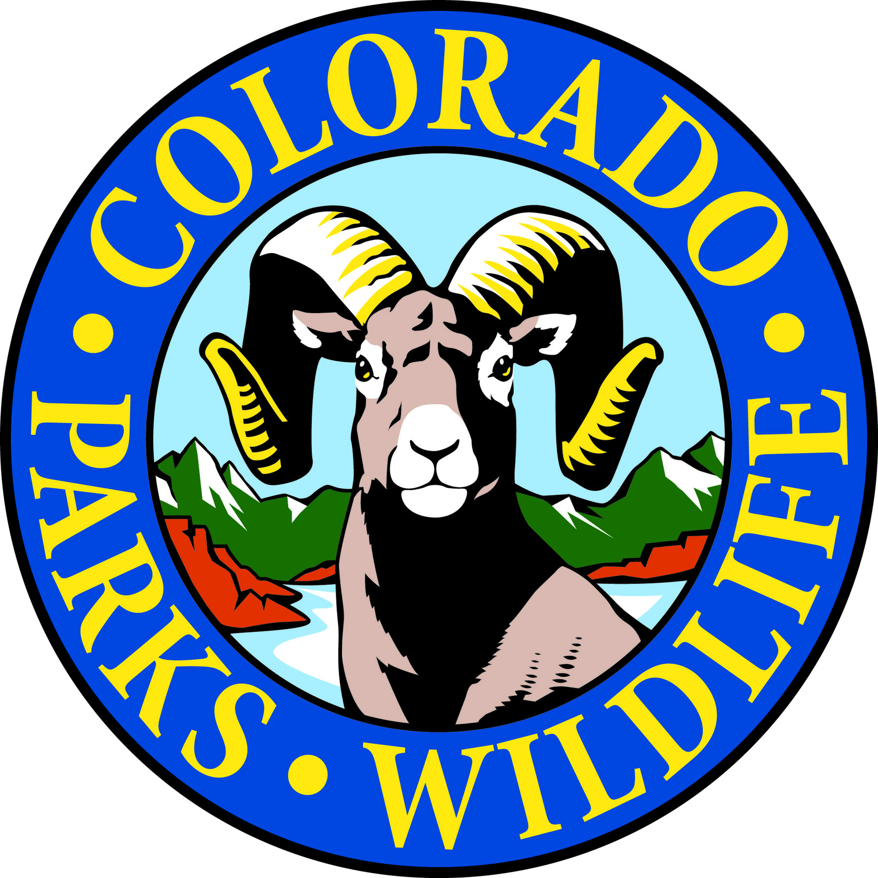

Cheyenne Mountain State Park

COLORADO SPRINGS, Colo. –Cheyenne Mountain State Park is located south of Colorado Springs at 410 JL Ranch Heights Road. Take Nevada Avenue south, which becomes Colorado State Highway 115 to JL Ranch Heights Road opposite the Main Gate One entrance to Fort Carson. Turn to the west to the park entrance. Programs are free unless otherwise noted, but vehicles entering the park must have a $7 daily or $70 annual State Parks pass. For more information, call 719-576-2016.

May Programs 2017
Tuesday, May 2

Program: Bird Hike
Time: 7:30 a.m. - 9:00 a.m.
Location: Cheyenne Mountain State Park Visitor Center
Details: It’s migration time! Join birding experts Charlie Campbell and Barry Cooper on an easy hike to look for and identify both resident and migratory bird species. We recommend that you bring water, binoculars, and a notepad. We have some binoculars you may borrow if you wish. No experience necessary. Recommended for ages 7 and up. Closed-toe shoes required. Hiking shoes recommended. State Park’s pass is required (Daily $7, Annual $70).
Information: 719-576-2016, www.cpw.state.co.us

Saturday, May 6
Program: Hummingbirds!
Time: 7:00 p.m. - 8:00 p.m.
Location: Cheyenne Mountain State Park Prairie Falcon Amphitheatre
Details: Discover the secrets of the smallest birds in the world and become a “hummingbird expert!” All ages are welcome to come learn all about hummingbirds at this engaging talk in the park’s amphitheatre with volunteer naturalist Kris Baril. State Park’s pass is required (Daily $7, Annual $70).
Information: 719-576-2016, www.cpw.state.co.us

Tuesday, May 9

Program: Bird Hike
Time: 7:30 a.m. - 9:00 a.m.
Location: Cheyenne Mountain State Park Visitor Center
Details: It’s migration time! Join birding experts Charlie Campbell and Barry Cooper on an easy hike to look for and identify both resident and migratory bird species. We recommend that you bring water, binoculars, and a notepad. We have some binoculars you may borrow if you wish. No experience necessary. Recommended for ages 7 and up. Closed-toe shoes required. Hiking shoes recommended. State Park’s pass is required (Daily $7, Annual $70).
Information: 719-576-2016, www.cpw.state.co.us

Wednesday, May 10
Program: Wildflower Hike
Time: 9:00 a.m. - 11:00 a.m.
Location: Cheyenne Mountain State Park Visitor Center
Details: Wednesday Wildflower Walks begin again! This is a beautiful, easy guided nature walk with volunteer naturalist Lucy Bell, that lasts about an hour and a half and focuses on all the wonderful wildflowers that can be found around the Park. Recommended for ages 7 and up. Closed-toe shoes required. Hiking shoes recommended. State Park’s pass is required (Daily $7, Annual $70).
Information: 719-576-2016, www.cpw.state.co.us

Program: Full Moon Hike
Time: 7:30 p.m. - 9:00 p.m.
Location: Cheyenne Mountain State Park Camper Services
Details: Join us on this one and a half hour full moon evening stroll as we explore moonlit landscapes, discover the nocturnal activities of nighttime creatures, and celebrate the Flower moon! This is a naturalist-guided easy hike. Recommended for ages 7 and up. Closed-toe shoes required. Hiking shoes recommended. State Park’s pass is required (Daily $7, Annual $70). Information: 719-576-2016, www.cpw.state.co.us

Saturday, May 13
Program: Women’s Beginning Archery Class
Time: 9:00 a.m. – 11:00 a.m.
Location: Cheyenne Mountain State Park Archery Range
Details: Join other women and give archery a try, or polish up skills you already have! One on one instruction will help students learn how to shoot. All equipment is provided. Reservations are required and the class is limited to 12 students. State Park’s pass is required (Daily $7, Annual $70).You may purchase a park pass at the Archery Range with cash or with a different form of payment at the Visitor Center or Entrance Station.
Information: 719-576-2016, www.cpw.state.co.us

Program: Archery Practice
Time: 11:00 a.m. – 12:00 p.m.
Location: Cheyenne Mountain State Park Archery Range
Details: For those who have completed our beginning archery class, we are offering a practice session to hone your skills. Equipment and instruction provided. Reservations required. State Park’s pass is required (Daily $7, Annual $70). You may purchase a park pass at the Archery Range with cash, or with a different form of payment at the Visitor Center or Entrance Station. Information: 719-576-2016, www.cpw.state.co.us

Saturday, May 13

Program: Discovery Hike for Moms (and anyone else that wants to come along)
Time: 11:00 a.m. – 12:30 p.m.
Location: Cheyenne Mountain State Park Limekiln Trailhead
Details: Join us for a hike on an easy trial as we celebrate Moms! You’ll get to explore a trail with a naturalist and see what you can discover along the way using binoculars, magnifying glasses, and other tools of the trade. Closed-toe shoes required. Hiking shoes recommended. State Park’s pass is required (Daily $7, Annual $70).
Information: 719-576-2016, www.cpw.state.co.us

Tuesday, May 16

Program: Bird Hike
Time: 7:30 a.m. - 9:00 a.m.
Location: Cheyenne Mountain State Park Visitor Center
Details: It’s migration time! Join birding experts Charlie Campbell and Barry Cooper on an easy hike to look for and identify both resident and migratory bird species. We recommend that you bring water, binoculars, and a notepad. We have some binoculars you may borrow if you wish. No experience necessary. Recommended for ages 7 and up. Closed-toe shoes required. Hiking shoes recommended. State Park’s pass is required (Daily $7, Annual $70).
Information: 719-576-2016, www.cpw.state.co.us

Saturday, May 20

Event: Kids to Parks Day
Time: 10:00 a.m. – 2:00 p.m.
Location: Cheyenne Mountain State Limekiln Trailhead
Details: Join us as we celebrate Kids to Parks Day sponsored by the National Park Trust. We will have all kinds of fun activities including archery, skins and skulls interactive display, hikes, and crafts. Event and activities are free but a State Park’s pass is required (Daily $7, Annual $70).
Information: 719-576-2016, www.cpw.state.co.us

Tuesday, May 23

Program: Bird Hike
Time: 7:30 a.m. - 9:00 a.m.
Location: Cheyenne Mountain State Park Visitor Center
Details: It’s migration time! Join birding experts Charlie Campbell and Barry Cooper on an easy hike to look for and identify both resident and migratory bird species. We recommend that you bring water, binoculars, and a notepad. We have some binoculars you may borrow if you wish. No experience necessary. Recommended for ages 7 and up. Closed-toe shoes required. Hiking shoes recommended. State Park’s pass is required (Daily $7, Annual $70).
Information: 719-576-2016, www.cpw.state.co.us

Wednesday, May 24
Program: Wildflower Hike
Time: 9:00 a.m. - 11:00 a.m.
Location: Cheyenne Mountain State Park Visitor Center
Details: Wednesday Wildflower Walks begin again! This is a beautiful, easy guided nature walk that lasts about an hour and a half and focuses on all the wonderful wildflowers that can be found around the Park. Recommended for ages 7 and up. Closed-toe shoes required. Hiking shoes recommended.
State Park’s pass is required (Daily $7, Annual $70). Information: 719-576-2016, www.cpw.state.co.us

Saturday, May 27
Program: Literary Walk
Time: 9:30 a.m. - 11:30 a.m.
Location: Cheyenne Mountain State Park Visitor Center
Details: The ever popular Literary Walk in the Woods returns for another season! Join us as we launch the fifth season of our unique “A Literary Walk in the Woods” program. This hike will be led by nationally known storyteller and writer, John Stansfield who will be leading the hike in character, portraying Dr. Charles Fox Gardiner, who came to Colorado in 1883.
The program will begin in the classroom with a biography of the author. We will then go on a one-mile nature walk on Zook Loop Trail and make a stop at the Rock Garden where we will hear selections from the author’s work. For your comfort, consider bringing a lightweight folding chair or mat to sit on. Event is free but, a State Park’s pass is required (Daily $7, Annual $70). Information: 719-576-2016, www.cpw.state.co.us
Program: Photo Seminar with Hiking Bob
Time: 9:00am
Location: Camper Services Meeting Room
Details: Want to learn how to take great wildflower pictures and where to find the best spots? Join award-winning photographer Bob "Hiking Bob" Falcone for this one hour seminar. Whether you have point-and-shoot, DSLR or cell phone camera, this seminar is for you. As an added bonus, you can also sign up for an hour "in the field" with Bob for some hands-on pointers
Information: 719-576-2016, www.cpw.state.co.us

Program: Mystery Hike
Time: 1:00 p.m. – 2:30 p.m.
Location: Cheyenne Mountain State Park Camper Services
Details: This naturalist-led hike challenges participants to solve a puzzle, riddle or mystery as they search for hidden clues along a one-mile or less, easy trail. We have eight different mystery hikes, so come see which one needs to be solved today! Recommended for ages 4 years and up. Children must be accompanied by an adult. Closed-toe shoes required. Hiking shoes recommended. Reservations requested and State Park’s pass is required (Daily $7, Annual $70). Information: 719-576-2016, www.cpw.state.co.us

Program: Campfire Talk
Time: 7:30 p.m. – 8:30 p.m.
Location: Cheyenne Mountain State Park Prairie Falcon Amphitheatre
Details: Join us around the campfire to learn about various topics relating to Cheyenne Mountain State Park. All programs will host a fire, and complimentary S’mores for guests who attend the program. State Park’s pass is required (Daily $7, Annual $70). Information: 719-576-2016, www.cpw.state.co.us

Tuesday, May 30

Program: Bird Hike
Time: 7:30 a.m. - 9:00 a.m.
Location: Cheyenne Mountain State Park Visitor Center
Details: It’s migration time! Join birding experts Charlie Campbell and Barry Cooper on an easy hike to look for and identify both resident and migratory bird species. We recommend that you bring water, binoculars, and a notepad. We have some binoculars you may borrow if you wish. No experience necessary. Recommended for ages 7 and up. Closed-toe shoes required. Hiking shoes recommended. State Park’s pass is required (Daily $7, Annual $70).
Information: 719-576-2016, www.cpw.state.co.us

Ongoing 2017 Programs

Programs: CMSP Trail Challenge and 100 Mile Trail Challenge
Time: Ongoing! Begins Jan. 1st, 2017 – Ends Dec. 31st, 2017
Location: Cheyenne Mountain State Park Trail System
Details: Join the 200+ participants who have already decided to take our challenge! The goal of the Cheyenne Mountain State Park Trail Challenge is to complete ALL 18 of the existing trails for a total of 21.87 miles. Not enough of a challenge for you? The 100 Mile Trail Challenge goal is to log 100 miles of trail within the park. This challenge is a go-at-your-own-pace kind of challenge. A quick sign up is necessary and sign-up sheets will be available at the visitor center anytime after Jan 1st. All miles must be logged and checked off by staff. Completion of the Trail Challenge will earn a special patch and the 100 Mile completers will earn a CMSP Challenge Coin.

The challenge is free but a valid parks pass is required on all vehicles entering the park (Daily $7, Annual $70). Information: 719-576-2016, www.cpw.state.co.us

Every Monday, Wednesday, and Saturday
Program: Yoga in the Park Time: 9:00 a.m.
Location: Visitor Center Meeting Room
Details: What better setting for a morning workout than Cheyenne Mountain State Park! Join certified instructor Sudhanshu Semwal for Sankalp Yoga every Monday, Wednesday, and Saturday. Beginners are welcome. Dates, times, and locations are subject to change. Call 719-576-2016 to confirm classes or sign up for the weekly email reminder.
Donations are appreciated and a valid parks pass is required on all vehicles entering the park.
Information: 719-576-2016, www.cpw.state.co.us

