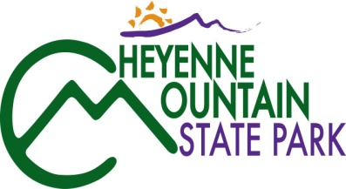
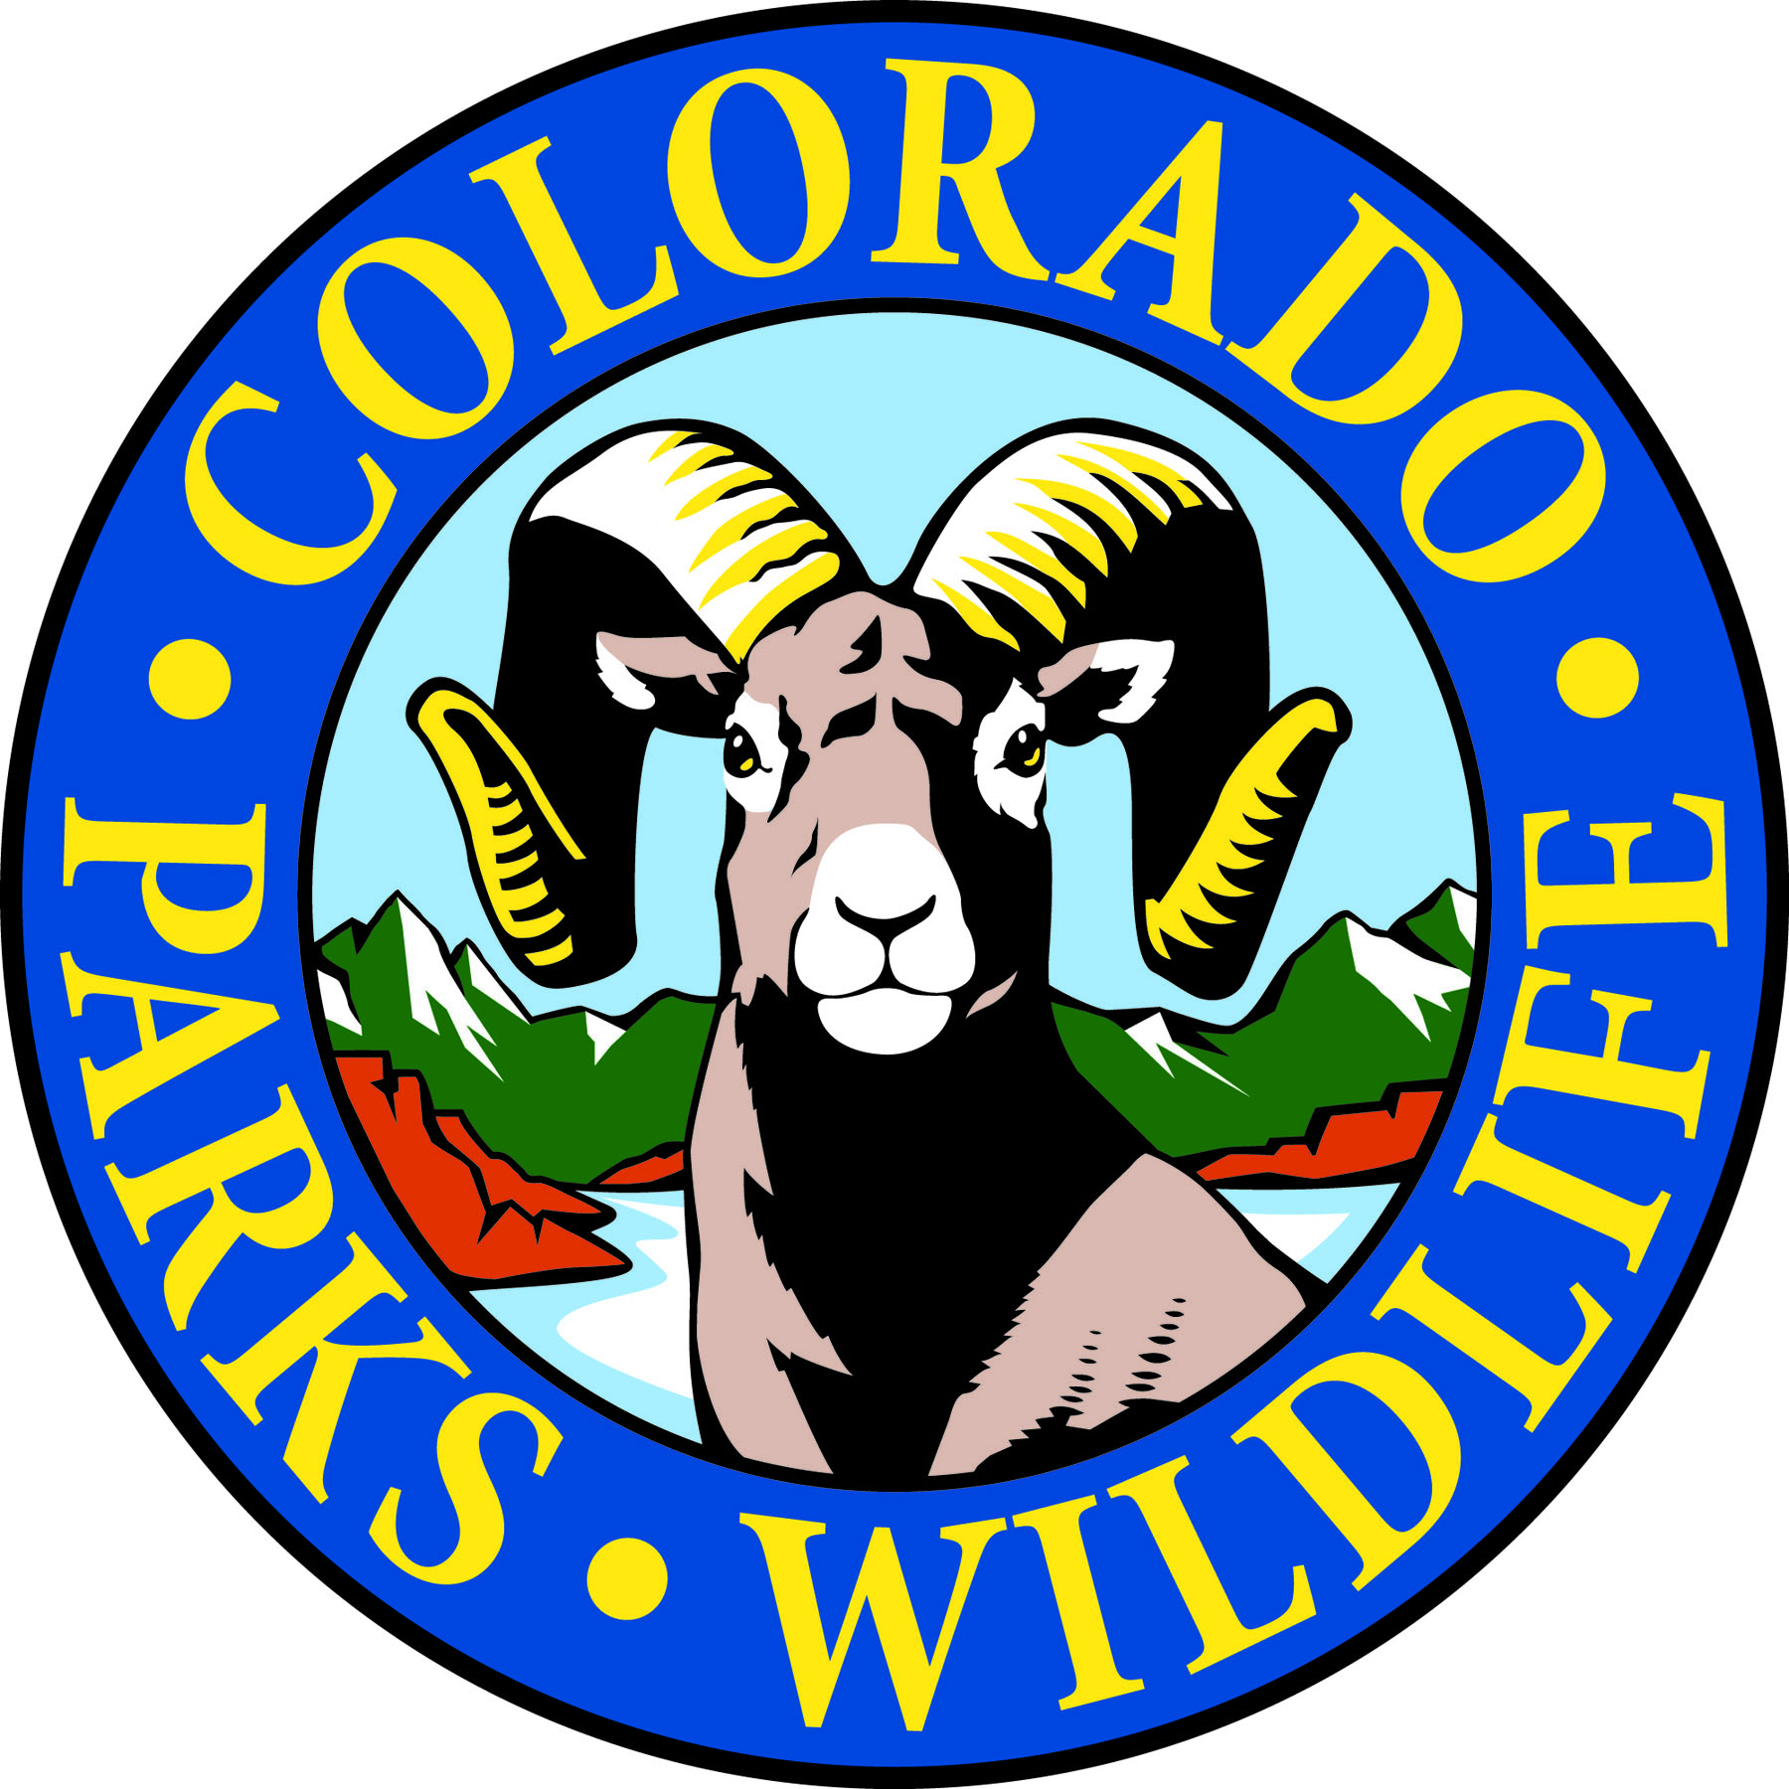

Cheyenne Mountain State Park

COLORADO SPRINGS, Colo. –Cheyenne Mountain State Park is located south of Colorado Springs at 410 JL Ranch Heights Road. Take Nevada Avenue south, which becomes Colorado State Highway 115 to JL Ranch Heights Road opposite the Main Gate One entrance to Fort Carson. Turn to the west to the park entrance. Programs are free unless otherwise noted, but vehicles entering the park must have a $7 daily or $70 annual State Parks pass. For more information, call 719-576-2016.

March Programs 2017

Saturday, March 18 and Sunday March 19th

Program: Animal Fur and Winter’s Burr
Time: 1:00 pm
Location: Cheyenne Mountain State Park Visitor Center
Details: How do you keep warm in the winter? Preschool children will learn how different animals keep warm in the cold weather. Children will also create a winter art scene. Be prepared to go outside for a short hike if the weather is good.

The program is free but a valid parks pass is required on all vehicles entering the park.
Registration is required by calling the park. Appropriate for ages 3-6, children must be accompanied by an adult throughout the program.

Information: 719-576-2016, www.cpw.state.co.us

Ongoing 2017 Programs

Programs: CMSP Trail Challenge and 100 Mile Trail Challenge
Time: Ongoing! Begins Jan. 1st, 2017 – Ends Dec. 31st, 2017
Location: Cheyenne Mountain State Park Trail System
Details: Join the 200+ participants who have already decided to take our challenge! The goal of the Cheyenne Mountain State Park Trail Challenge is to complete ALL 18 of the existing trails for a total of 21.87 miles. Not enough of a challenge for you?? The 100 Mile Trail Challenge goal is to log 100 miles of trail within the park. This challenge is a go-at-your-own-pace kind of challenge. A quick sign up is necessary and sign up sheets will be available at the visitor center anytime after Jan 1st. All miles must be logged and checked off by staff. Completion of the Trail Challenge will earn a special patch and the 100 Mile completers will earn a CMSP Challenge Coin.

The challenge is free but a valid parks pass is required on all vehicles entering the park.
Information: 719-576-2016, www.cpw.state.co.us

Every Monday, Wednesday, and Saturday
Program: Yoga in the Park Time: 9:00 a.m.
Location: Visitor Center Meeting Room
Details: What better setting for a morning workout than Cheyenne Mountain State Park! Join certified instructor Sudhanshu Semwal for Sankalp Yoga every Monday, Wednesday, and Saturday. Beginners are welcome. Dates, times, and locations are subject to change. Call 719-576-2016 to confirm classes or sign up for the weekly email reminder.
Donations are appreciated and a valid parks pass is required on all vehicles entering the park.
Information: 719-576-2016, www.cpw.state.co.us

Looking Forward! Programs
(These programs are NOT available for registration yet)

Program: Beginning Archery Classes
Details: Set to begin as early as April, the ever-popular beginning archery classes will be held a couple times a month throughout the summer and well into Sept. We will be adding new, fun class ideas along with returning “practice” sessions available for those that have taken the first class and want more practice time! Equipment will be provided. Registrations will not be taken until class times and dates are released. These fill up quickly so keep an eye out!

Program: Wildflower Wednesdays
Details: These beautiful hikes are led by an amazing crew of wildflower specialists! They will be held twice a month on Wednesday mornings from 9:00 to 11:00a.m. Hikes will begin in May and end in August.

Program: Literary Walk in the Woods
Details: Back by popular demand is Lucy Bell’s Literary Walk in the Woods series! If this is one of your favorite programs, keep an eye out for future advertisements and then call to reserve your place! These will be held once a month from May thru Aug. on Saturday mornings. Time has been adjusted per requests for an earlier (Cooler!) time of day!

