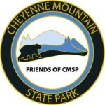

**Friends of Cheyenne Mountain State Park   
Winter Newsletter 2016**

**CONTENTS**  
**President's message**   
**Cheyenne Mountain Run Report**

**Volunteer Banquet**

**Visitor Center Landscape Project**

**Christmas Open House**

**Board Members**

**Dr. Glen and Barbara Scott tribute**

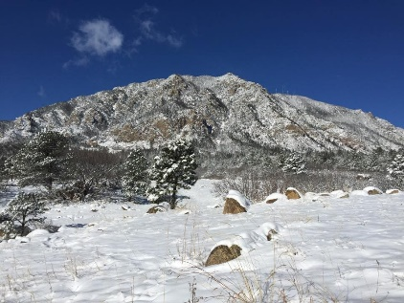

**2nd Annual Cheyenne Mountain Run!**

**Dear Friends,**   
2016 is wrapping up and we have so much to be thankful for this year! An increase in membership, incredible support from our members, a dedicated Board of Directors and multiple successful fund raising events. These activities enabled us to help Cheyenne Mountain State Park maintain amazing outdoor opportunities for our community and many visitors from across the area. of organizing 2017 goals and foremost in our vision is our commitment to CMSP. We strive to serve and protect the Park for present and future generations with the direction of our park manager, Mitch Martin.

Every success we attain is directly attributed to your support in our various projects and activities. Fund raising is essential to our continuing success and as you make your year end choices for giving, please consider Friends of CMSP. The following pages highlight activities and projects that we helped achieve in the last few months, please share in our joy.

**Happy Trails and Holiday Cheer to All…**

Pat Cooper, President  
Friends of Cheyenne Mountain State Park

We are in the midst

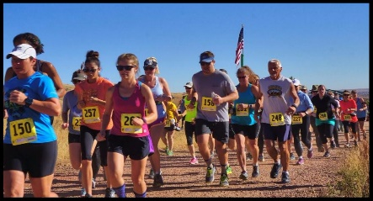

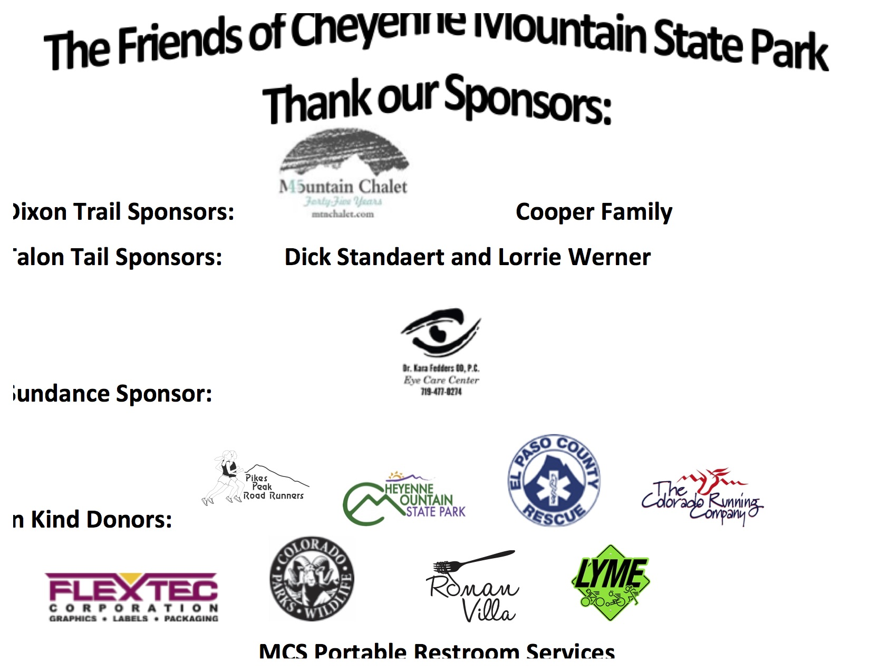

**THANKS TO OUR RACERS, VOLUNTEERS and SPONSORS!!**

We had 279 registered racers - A 30% increase

We raised $7K +/- that will pay for more work on the Dixon trail!

**Save the date - October 21, 2017**

**3rd Annual Cheyenne Mountain Race!**

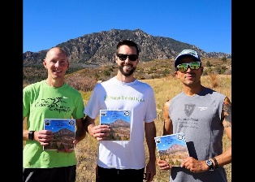 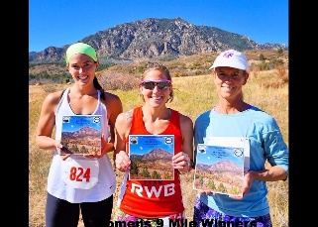

    For complete results please go to [http://www.friendsofcmsp.org](http://www.friendsofcmsp.org/" \t "_blank)

Select the Cheyenne Mountain Run tab.

**Women 9M Winners  L-R**  
*2nd*  Jess Kraiza, 1:30:20 CT

*1st*  Emily Valencia, 1:28:24, Fort Carson

*3rd*  Laura Kelecy, 1:34:04 Colo Spgs.

**Men Winners 9M L-R**   
3rd Duane Roberson,1:09:00,  Colo Spgs

1st  Payton Batliner, 1:01:25,  Denver

2nd Gerald Romero,1:06:33   Colo Spgs

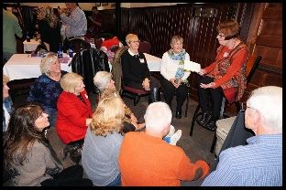 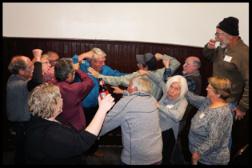 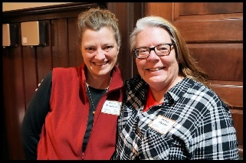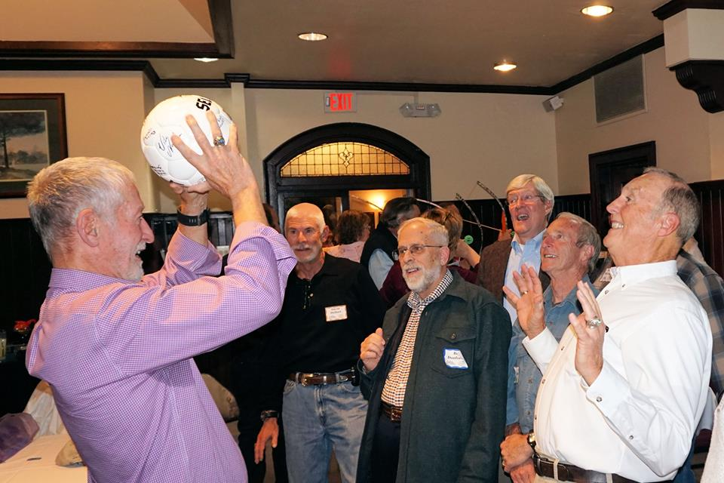

**VOLUNTEER BANQUET**  - November 17th. We had a great time with our attempt at a Mannequin Challenge. 

**Left**-Lucy Bell reading from her new book.  **CL**-Ralph Cadwallader and Sam Koury duking it out. **CR**-Jena Sanchez, CPW staff and Darcy Mount, Sr Ranger, CMSP.  **R –** Attempt at Volleyball from a previous Coach.

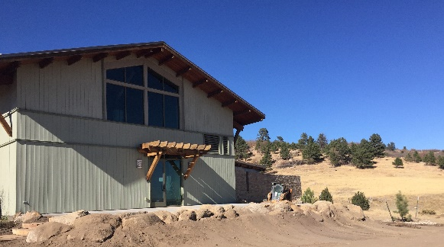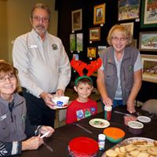

**Annual Christmas Open House – December 3rd**

Activities for the kids, warmth around the fireplace, good friends, hot drinks and holiday food contributed to a festive afternoon.

**Visitor Center East Landscape Project**

A new patio, planting new trees, boulders arranged and a beautiful stepping path to the front of the Visitor Center.   
We were successful in obtaining a grant from the Broadmoor Garden Club to help purchase native plants for this project. More to come in the Spring of 2017.

Dr. Glen Scott and Barbara Scott have retired from the Friends Board and they will be greatly missed.  Dr. Scott was one of the founding members of the Friends in 2001 when the park was just an idea.  He has served as President, Vice President and General Board member.  His wife Barb has been a volunteer at CMSP since 2006 and served as FCMSP Treasurer since 2008.  We are grateful for their efforts to make CMSP a great state park and wish them well in their future.  
We welcome Pam Scott as our new Treasurer. She has been a Volunteer since the park opened and active in the Archery and Geocaching programs. R-Dr. Glen and Barb Scott receiving Awards for their many years of service from Pat Cooper and Mitch Martin, Park Manager.

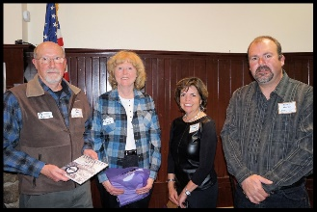

***“Be a Friend”***  
Membership types: Individual, Family, Contributing, Business and Life.

Join on line at: Friendsofcmsp.org or pick up information at the Visitor Center, Winter hours 9 A to 4P, everyday.

**2017 BOARD MEMBERS  
  
President                  Pat Cooper  
1st Vice President   Lori O'Hare  
Secretary                   Susan Simmons  
 Treasurer                 Pam Scott**

**Member at Large    Jack Busher**

**Membership             Ralph Cadwallader**

**Newsletter                 Jean Danforth**

**Social Media             Abbie Burke  
Member at Large     Warren Pierce**

**Non-Voting Member Mitch Martin**

*Do you shop Amazon? Amazon donates .05% of your purchases.  
Sign up at: https:// smile.amazon.com   
Select “Friends of CMSP” as your designated charity.*

**



**FOLLOW US:**

*Copyright © 2016 Friends of Cheyenne Mountain State Park, All rights reserved*

***Our mailing address is:*** *Friends of Cheyenne Mountain State Park 410 JL Ranch Heights, Colorado Springs, CO 80926*