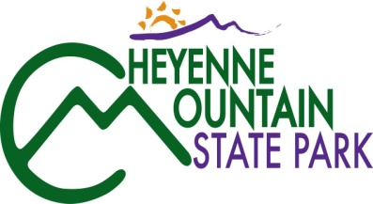
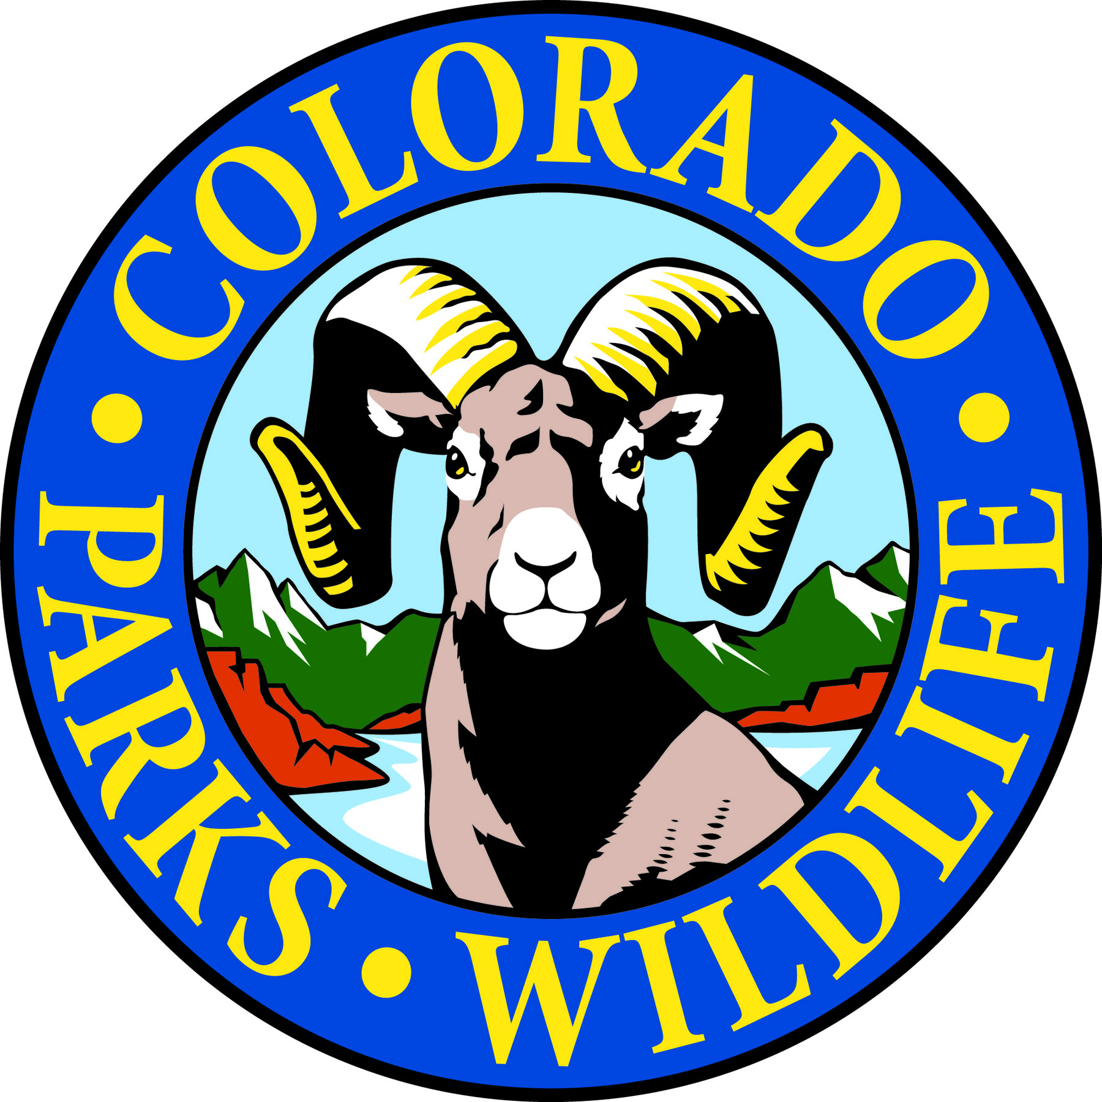

COLORADO SPRINGS, Colo. –Cheyenne Mountain State Park is located south of Colorado Springs at 410 JL Ranch Heights Road. Take Nevada Avenue south, which becomes Colorado State Highway 115 to JL Ranch Heights Road opposite the Main Gate One entrance to Fort Carson. Turn to the west to the park entrance. Programs are free unless otherwise noted, but vehicles entering the park must have a $7 daily or $70 annual State Parks pass. For more information, call 719-576-2016.

October Programs 2016

Saturday, October 1
Program: Skins and Skulls Interactive Display
Time: 10:00 a.m. – 1:00 p.m.
Location: Cheyenne Mountain State Park Visitor Center
All ages are welcome to stop by the skins and skulls display at the visitor center. Look—Touch—Discover!
Parks pass required. Information: 719-576-2016, www.cpw.state.co.us

Saturday, October 8
Program: Beginning Archery Class
Time: 9:00 a.m.
Location: Cheyenne Mountain State Park Archery Range
Details: Have you always wanted to shoot a bow and arrow like Legolas? Here is your chance to get started! One on one instruction will help students learn how to shoot. All equipment is provided. This class is for students 8 years old and up. Reservations are required and the class is limited to 12 students. You may purchase a park pass at the Archery Range with cash, or with a different form of payment at the Visitor Center or Entrance Station. Information: 719-576-2016, www.cpw.state.co.us

Program: Archery Practice
Time: 12:00 p.m.
Location: Cheyenne Mountain State Park Archery Range
Details: For those who have completed our beginning archery class, we are offering a practice session to hone your skills. Equipment and instruction provided. Reservations required.
Information: 719-576-2016, www.cpw.state.co.us

Saturday, October 15
Program: Discovery Hike
Time: 10:00 a.m. – 11:30 a.m.
Location: Cheyenne Mountain State Park Limekiln Trailhead
Details: A naturalist leads this hike using binoculars, magnifying lenses and other tools. Along this one mile easy trail, we will discover things big and small, close up and far away. Recommended for ages 4 years and up. Children must be accompanied by an adult. Parks pass required.
Information: 719-576-2016, www.cpw.state.co.us

Saturday, October 22

Program: 2nd Annual Cheyenne Mountain Run
Time: 10 a.m.- 1:00 p.m.
Location: Cheyenne Mountain State Park Limekiln Trailhead
This 9M/5K run is to benefit the construction of the Dixon Trail that will lead to the top of Cheyenne Mountain.
The 2016 race distance will be a little more than 9 miles and will increase each year as the trail to the top of the mountain is completed. When the trail is completed, this race will provide runners with a new challenging trail race that will be 12-13 miles long with about 3,000 feet of elevation gain and loss.

The most exciting part of this event is that the course will offer runners the ability to run on the finished portion of the Dixon Trail that is not open to the public yet!
Race information and online registration: www.friendsofcmsp.org

*The 9M race will start at 10:00 a.m.
*The 5K race will start at 10:15 a.m.

Saturday, October 29

Program: Pumpkin Fun Shoot
Times: 3 sessions!
10 a.m-11:00 a.m./ 11:30 a.m.-12:30 p.m./ 1:00 p.m.-2:00 p.m.
Location: Cheyenne Mountain State Park Archery Range
Details: Come out and have some fun at the archery range shooting at pumpkins and other Halloween themed decor!
All equipment is provided. This fun shoot is for ages 8 years old and up.
*Reservations are required* and each time slot is limited to 18 students (please only sign up for one time slot to allow as many people to participate as possible). You may purchase a park pass at the Archery Range with cash, or with a different form of payment at the Visitor Center or Entrance Station.
The wearing of costumes is encouraged!
Information and registration: 719-576-2016, www.cpw.state.co.us

