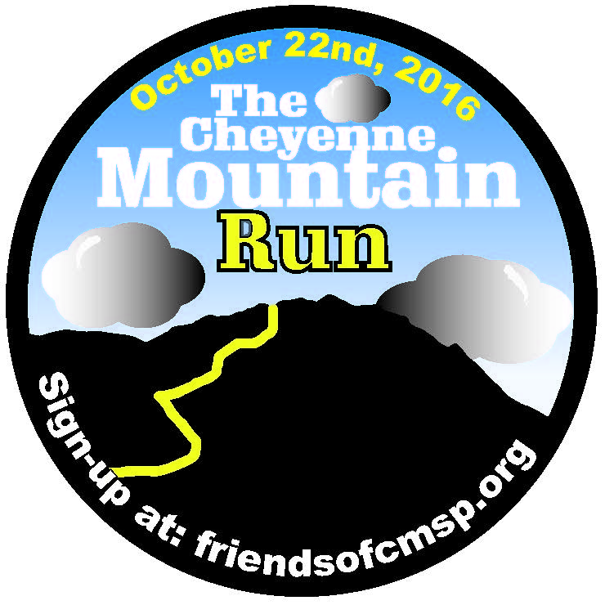
Second annual race will raise
funds for Dixon Trail to
Cheyenne Mountain summit

CHEYENNE MOUNTAIN STATE PARK – Tremendous progress has been made this year on construction of the new Dixon Trail to the summit of Cheyenne Mountain. A 3.6 mile loop on top of the mountain is complete and progress has been made both from the loop coming down the Dixon Trail and going up the Dixon Trail.
The Dixon Trail, which begins in Cheyenne Mountain State Park, will weave its way up the southeastern flanks of Cheyenne Mountain.
To help fund the trail-building efforts, the nonprofit organization Friends of Cheyenne Mountain State Park is inviting runners and hikers to the second Cheyenne Mountain Run set for 10 a.m., Oct. 22. Participants will have two options, a challenging 9.25-mile trail run that will include the completed portion of the Dixon Trail, or tackle a rolling 5K.
Dick Standaert, race director, said “in 2016 The Cheyenne Mountain Run will be 9.25 miles long and will be an out and back race that starts and finishes at the Limekiln trailhead. The first 4.6 miles of the race are uphill with the final 1.3 plus miles on the Dixon trail becoming progressively more difficult. The downhill return portion of the race follows the same trails to the finish. Total elevation gain and loss is about 1,200 feet. As new Dixon trail is completed each year the race will become longer. Once the trail is completed the race will be an out and back race to the top of Cheyenne Mountain.”
"When it comes to trail running, it's hard to beat the trails at Cheyenne Mountain State Park," says Tim Bergsten, owner and manager of the running website PikesPeakSports.us. "This is a legit trail race supporting a great cause. The Friends of Cheyenne Mountain State Park put on a quality event last year, so and I expect this race to grow in popularity."
“The net proceeds from our first race in 2015 were used to hire Rocky Mountain Trail Institute in July to start building the Dixon trail down the mountain. We have made tremendous progress this year and by participating in this event as a hiker or walker we will reach our goal of opening the trial to our community sooner.” said Pat Cooper, president of Friends of Cheyenne Mountain State Park
Registration is available at friendsofcmsp.org. Or, register in person at Cheyenne Mountain State Park. All participants will receive a race Tech-shirt and there will be overall and age-group awards.
The Dixon Trail is currently closed to the public. When it is finished, the new 3-mile-long trail will ascend about 3,000 feet connect with the Top of the Mountain Trail, a 3.6-mile loop, at 9,000 feet atop Cheyenne Mountain. The distance from the Limekiln Trailhead in Cheyenne Mountain State Park to the top of the Dixon Trail will be slightly over 6 miles, giving hikers and runners a roundtrip of nearly 12.5 miles.
The Fiends of CMSP is a 501 (c) 3 Non-profit organization
Race registration: Friendsofcmsp.org
Additional Contact information: friendsofcmsp@gmail.com Friends of CMSP-Pat Cooper 719-963-4654 Race Director: Dick Standaert, RSWWGENMGR@aol.com, 719-322-0574

