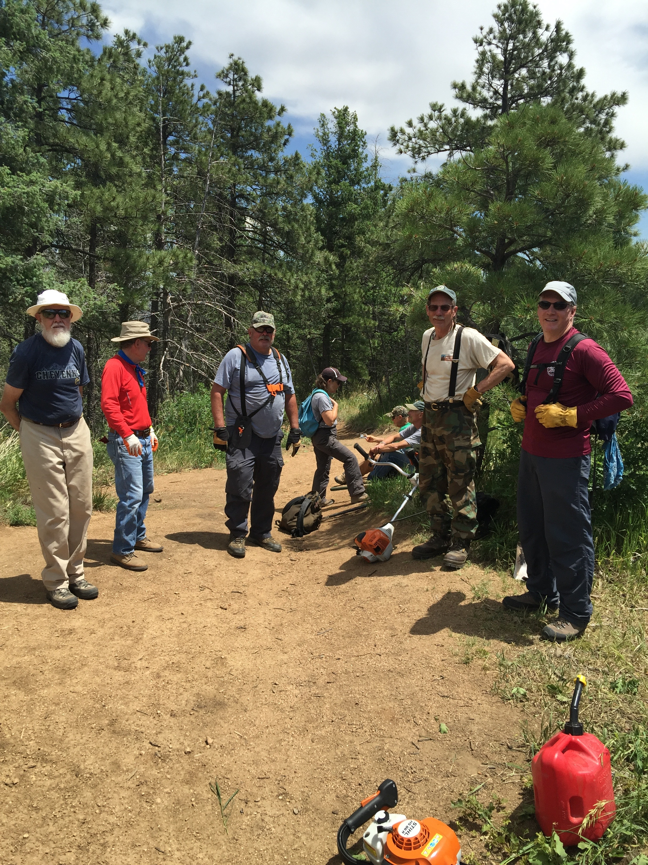
June 24, 2016

Trail Crew:
Jack Busher
Jim Mullen
Glenn Scadden
Ralph Cadwallader
Art Porter
John Etzel
Dan Downs
Denise Downs
Joel Marx
Tools:
Bladed Weed-whacker 1
Tri-blade Weed-whacker 1
String Weed-whacker
Hedge Trimmer 1
Gas 1
Loppers 2
Hand loppers 1
Shears
Pick-Mattock 2
Pulaski
Shovel 2
McLeod 2
Rake 2
Project: Finish Re-route on Talon + Corridor Clearing on Talon
Completed: Re-route completed; Corridor cleared from Re-route west to 300 yrds beyond N. Talon intersection
