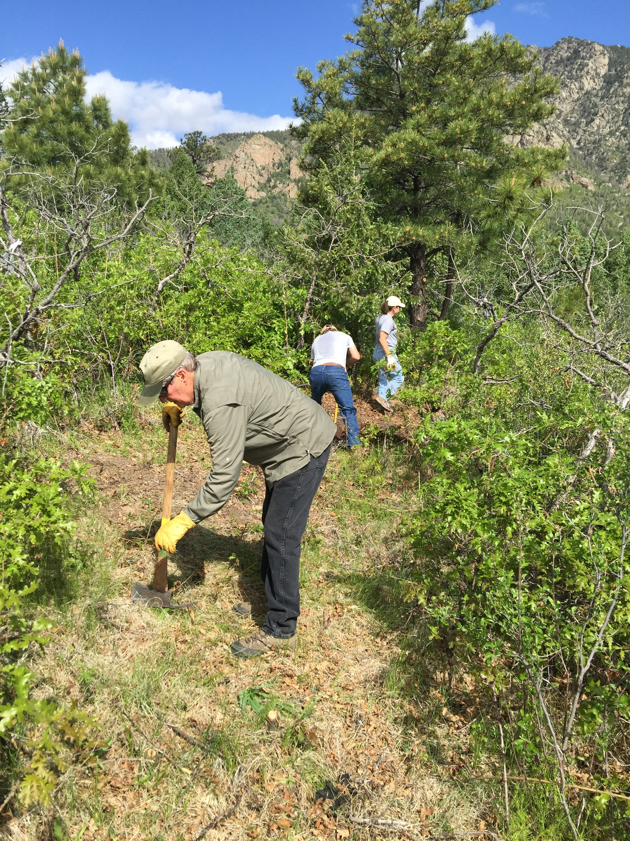
May 31, 2016

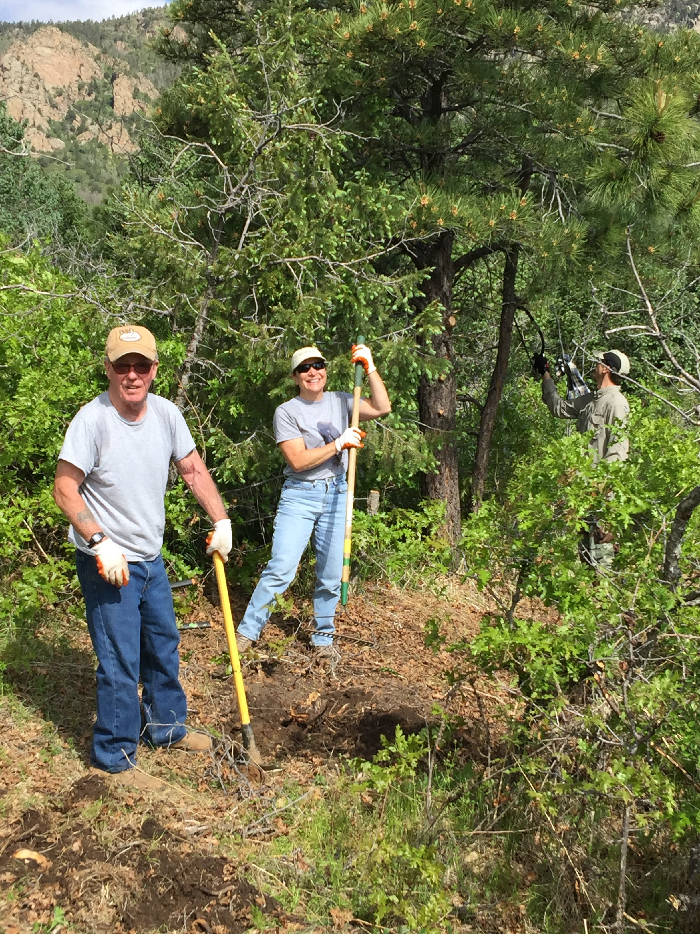
Trail Crew:
Jack Busher
Geof Durheim
Art Porter
Warren Pierce
Glen Scadden
Denise Downs
Dan Downs
Tools:
Lopper 1
Bow Saw 1
Marking Tape 1
Pick-mattock 3
Pulaski 1
Shovel 2
McLeod 2
Rake 2
Tamper 1
Projects: Re-route on Talon between GPS 8-9; establish tread; close old section
Completed: all but 30ft of tread

