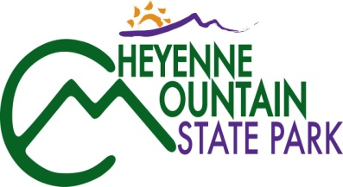
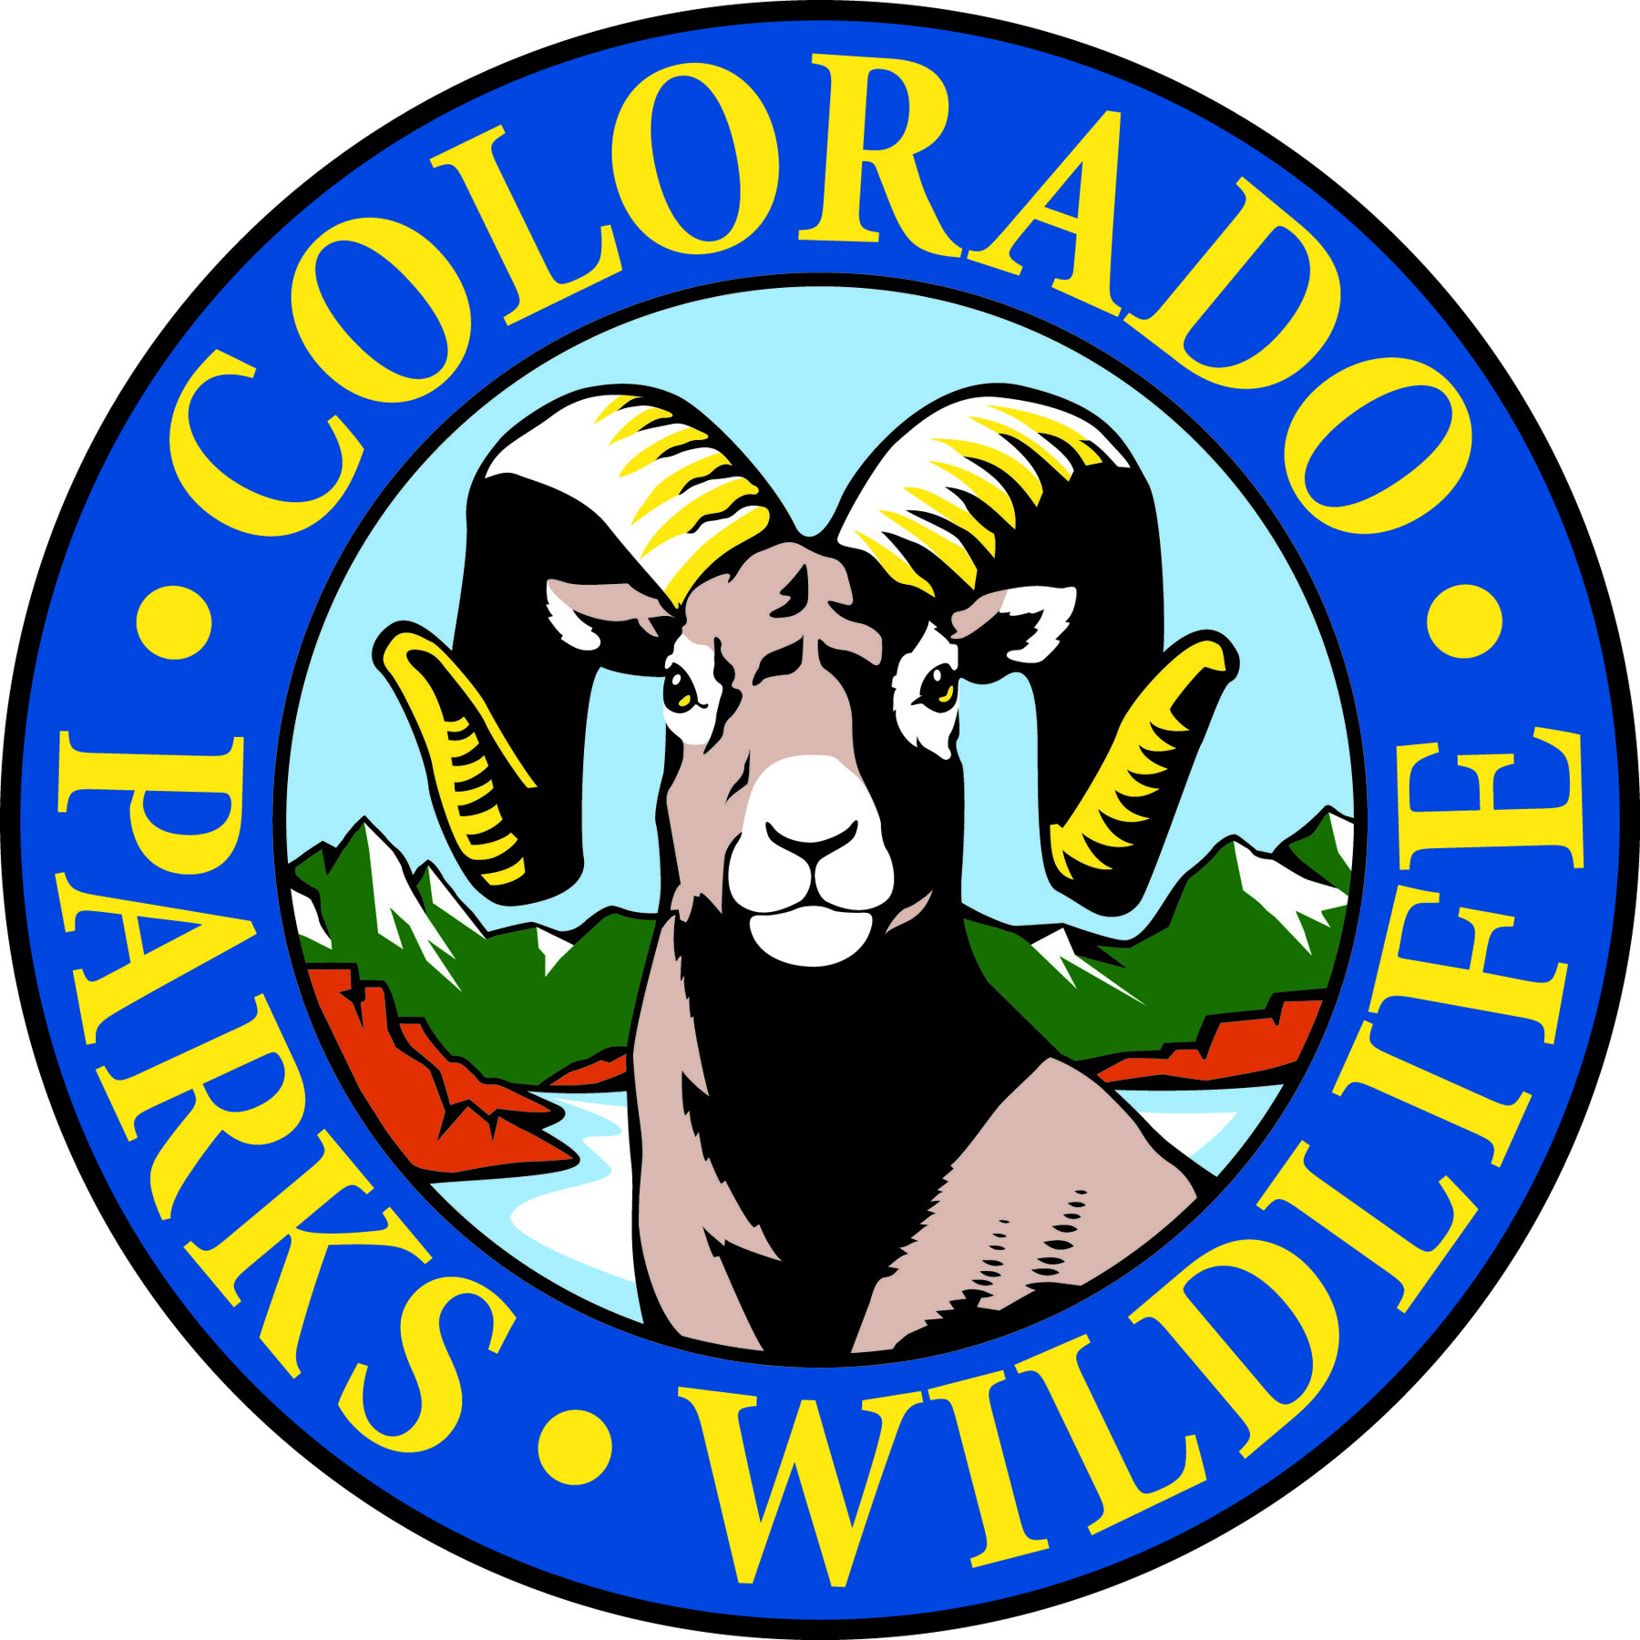

Cheyenne Mountain State Park is exploring Creatures of the Night on October 17th!

COLORADO SPRINGS, Colo. –Cheyenne Mountain State Park is located south of Colorado Springs at 410 JL Ranch Heights Road. Take Nevada Avenue south, which becomes Colorado State Highway 115 to JL Ranch Heights Road opposite the Main Gate One entrance to Fort Carson. Turn to the west to the park entrance. Programs are free unless otherwise noted, but vehicles entering the park must have a $7 daily or $70 annual State Parks pass. For more information, call 719-576-2016.

October Programs 2015

Every Wednesday and Saturday

Program: Yoga in the Park
Time: 9:00 a.m.
Location: Cheyenne Mountain State Park Visitor Center
Details: What better setting for a morning workout than Cheyenne Mountain State park. Join instructor Semwal for a yoga session every Wednesday and Saturday. Beginners welcome. Occasionally, classes are moved or cancelled.
Information: 719-576-2016, www.cpw.state.co.us

Saturday, October 3

Program: Family Mystery Hike
Time 1:00 p.m.
Location: Cheyenne Mountain State Park Visitor Center
Details: This naturalist-led hike challenges families to solve a puzzle, riddle or mystery as they search for hidden clues along a one mile easy trail. We have eight different mystery hikes so come see which one needs to be solved today. Recommended for ages 4 years and up. Children must be accompanied by an adult.
Information: 719-576-2016, www.cpw.state.co.us

Sunday, October 4

Program: YOUR Art in the Park!
Time: 1:00 p.m.
Location: Cheyenne Mountain State Park Visitor Center
Details: : Cheyenne Mountain State Park Visitor Center
Details: The Cheyenne Mountain State Park Visitor Center displays the work of local artists and you can come and create your own masterpiece to take home. Find your inspiration in a beautiful park setting. This program is for kids of all ages. Art supplies for your own creations and coloring pages for young and old are supplied.
Information: 719-576-2016, www.cpw.state.co.us

Saturday, October 10

Program: Beginning Archery
Time: 10 a.m.
Location: Cheyenne Mountain State Park Archery Range
Details: Have you always wanted to shoot like the Arrow or Katniss? Here is a way to get started! One on one instruction will help students learn how to shoot. All equipment is provided. This class is for students 8 years old and up. Reservations are required and the class is limited to 12 students.
Information: 719-576-2016, www.cpw.state.co.us

Program: Archery Practice
Time: 1:00 p.m.
Location: Cheyenne Mountain State Park Archery Range
Details: For those who have completed our beginning archery class, we are offering a practice session to hone your skills. Equipment and instruction provided. Reservations required.
Information: 719-576-2016, www.cpw.state.co.us

Program: Discovery Hike
Time: 1:00 p.m.
Location: Cheyenne Mountain State Park Visitor Center.
Description: A naturalist leads this hike using binoculars, magnifying lenses and other tools. Along this one mile easy trail we find things big and small, close up and far away. Recommended for ages 4 years and up. Children must be accompanied by an adult.
Information: 719-576-2016, www.cpw.state.co.us

Sunday, October 11

Program: Family Mystery Hike
Time 1:00 p.m.
Location: Cheyenne Mountain State Park Visitor Center
Details: This naturalist-led hike challenges families to solve a puzzle, riddle or mystery as they search for hidden clues along a one mile easy trail. We have eight different mystery hikes so come see which one needs to be solved today. Recommended for ages 4 years and up. Children must be accompanied by an adult.
Information: 719-576-2016, www.cpw.state.co.us

Saturday, October 17

Program: Creatures of the Night
Time: 2:00 to 4:00 p.m.
Location: Cheyenne Mountain State Park Visitor Center
Details: Come join us for an evening of fun activities and learn about nighttime adaptations of animals like bats, owls and other creatures of the night.
Information: 719-576-2016; www.cpw.state.co.us

Sunday, October 18

Program: Owls
Time: 1 p.m.
Location: Cheyenne Mountain State Camper Services
Details: We will explore the different species of owls that live here. Learn how these birds are adapted to nighttime flying and hunting.
Information: 719-576-2016, www.cpw.state.co.us

Saturday, October 24

Program: Cheyenne Mountain Run
Time: 8 a.m.
Location: Cheyenne Mountain State Park Limekiln Trailhead
This 8 mile/5 K run is to benefit the construction of the Dixon Trail that will lead to the top of Cheyenne Mountain. The most exciting part of this event is that the 8-mile course will offer our runners the ability to run on the finished portion of the Dixon Trail that is not open to the public yet!
Race information and online registration: friendsofcmsp.org

Program: Discovery Hike
Time: 1:00 p.m.
Location: Cheyenne Mountain State Park Visitor Center.
Description: A naturalist leads this hike using binoculars, magnifying lenses and other tools. Along this one mile easy trail we find things big and small, close up and far away. Recommended for ages 4 years and up. Children must be accompanied by an adult.
Information: 719-576-2016, www.cpw.state.co.us

Saturday, October 31

Program: Pumpkin Fun Archery Shoot
Time: 10 a.m.
Location: Cheyenne Mountain State Park Archery Range
Details: Come learn the sport of archery by shooting at pumpkins! One on one instruction will help students learn how to shoot. All equipment is provided. This class is for students 8 years old and up. Reservations are required and the class is limited to 12 students.
Information: 719-576-2016, www.cpw.state.co.us

Program: Pumpkin Fun Archery Shoot
Time: 1 p.m.
Location: Cheyenne Mountain State Park Archery Range
Details: Come learn the sport of archery by shooting at pumpkins! One on one instruction will help students learn how to shoot. All equipment is provided. This class is for students 8 years old and up. Reservations are required and the class is limited to 12 students.
Information: 719-576-2016, www.cpw.state.co.us

