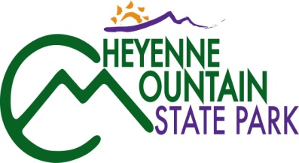
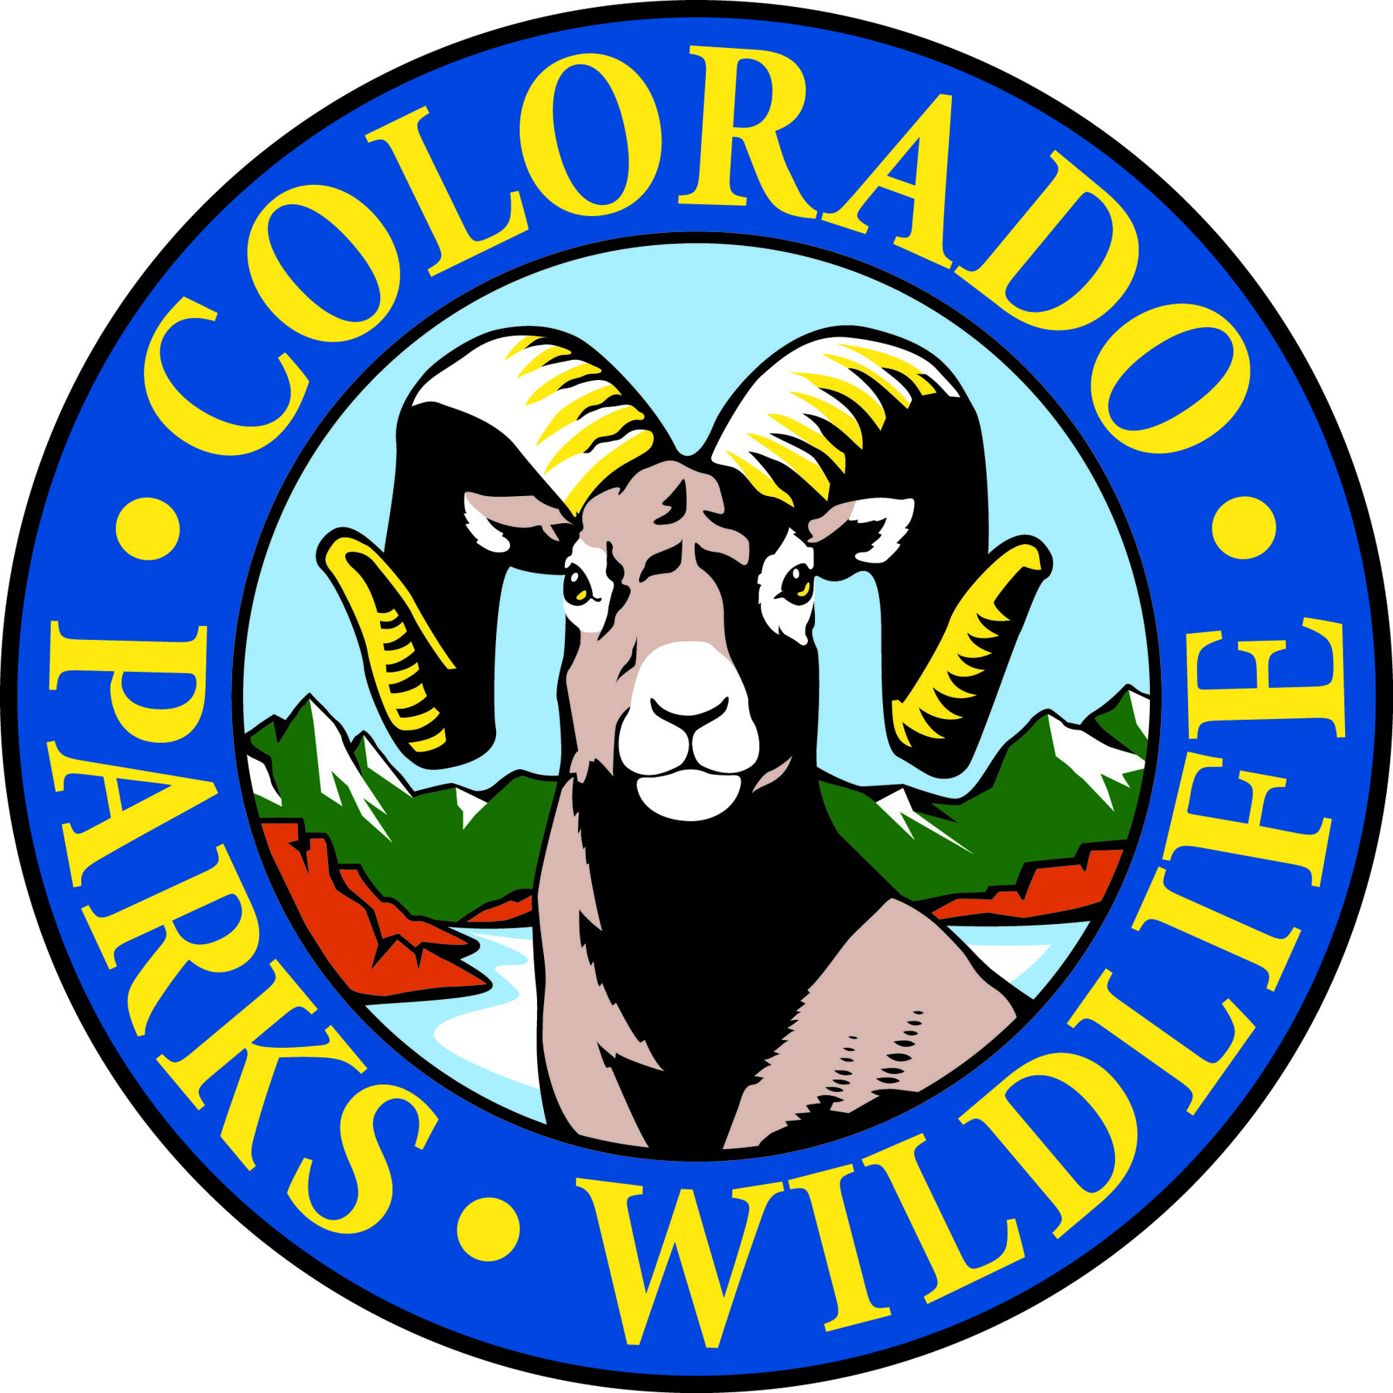

Cheyenne Mountain State Park is celebrating Western Heritage Day on July 3rd!

COLORADO SPRINGS, Colo. –Cheyenne Mountain State Park is located south of Colorado Springs at 410 JL Ranch Heights Road. Take Nevada Avenue south, which becomes Colorado State Highway 115 to JL Ranch Heights Road opposite the Main Gate One entrance to Fort Carson. Turn to the west to the park entrance. Programs are free unless otherwise noted, but vehicles entering the park must have a $7 daily or $70 annual State Parks pass. For more information, call 719-576-2016.

July Programs 2015

Every Wednesday and Saturday

Program: Yoga in the Park
Time: 9:00 a.m.
Location: Cheyenne Mountain State Park Visitor Center
Details: What better setting for a morning workout than Cheyenne Mountain State park. Join instructor Semwal for a yoga session every Wednesday and Saturday. Beginners welcome. Occasionally, classes are moved or cancelled.
Information: 719-576-2016, www.cpw.state.co.us

Wednesday, July 1

Program: Wildflower Wednesday Walk
Time: 9:00 a.m.
Location: Cheyenne Mountain State Park Visitor Center
Details: Bring your camera, water and a notepad and join volunteer park naturalists, Pat Cooper and Lucy Bell, on a one and a half hour nature hike to see what’s blooming in the park this week. Reservations required.
Information: 719-576-2016, www.cpw.state.co.us

Thursday, July 2

Program: Full Moon Hike
Time: 8:30 p.m.
Location: Cheyenne Mountain State Park Visitor Center Parking Lot
Details: Join us on this one and a half hour guided evening stroll as we explore moonlit landscapes and discover the nocturnal activities of owls and other nighttime creatures. Bring a flashlight. Reservations requested.
Information: 719-576-2016, www.cpw.state.co.us

Friday, July 3

Program: Western Heritage Day!
Time: 4:00 p.m.-7:00 p.m. Activities, 7:00 p.m. Live music and fireworks
Location: Cheyenne Mountain State Park Prairie Skipper Pavilion
Details: Come celebrate a Western Independence Day a day early at Cheyenne Mountain State Park! From 4:00 to 7:00 p.m. come play games, make ranch crafts, and throw horseshoes. You can spit watermelon seeds, dress up like a ranch hand, and practice your roping. Enjoy live flute and guitar music from 7:00 to 8:00 p.m. by Lex Nichols. Plus we will tell cowboy jokes and sing songs until the Fort Carson fireworks start. State Parks pass required.
Information: 719-576-2016, www.cpw.state.co.us

Saturday, July 4

Program: Junior Ranger Class – Birds and Binoculars
Time: 1:00 p.m.
Location: Cheyenne Mountain State Park Camper Services
Details: Do you have the right stuff to be a Junior Park Ranger? Learn how to use binoculars and pick up tips on bird identification. Pick up a Junior Ranger training booklet at the Visitor Center or at class. Kids 7-12 years old can earn a Junior Ranger badge and/or a colorful patch depending on levels completed.
Information: 719-576-2016, www.cpw.state.co.us

Sunday, July 5

Program: Family Mystery Hike
Time 1:00 p.m.
Location: Cheyenne Mountain State Park Visitor Center
Details: This naturalist-led hike challenges families to solve a puzzle, riddle or mystery as they search for hidden clues along a one mile easy trail. We have eight different mystery hikes so come see which one needs to be solved today. Recommended for ages 4 years and up. Children must be accompanied by an adult.
Information: 719-576-2016, www.cpw.state.co.us

Friday, July 10

Program: Fitness Hike
Time: 9:00 a.m.
Location: Cheyenne Mountain State Park Visitor Center
Details: If you’re interested in burning some calories on the trails and enjoying some great views, this is the place to be. Join us for your choice of beginning, intermediate or advanced hikes.
Information: 719-576-2016, www.cpw.state.co.us

Program: The Truth about Rattlesnakes
Time: 7:00 p.m.
Location: Cheyenne Mountain State Park Camper Services Activity Room
Volunteer park naturalist, Barry Cooper, gives us the straight scoop on rattlesnakes as he shares his experiences growing up on a ranch. He will share his knowledge of rattlesnake behavior and life cycle.
Information: 719-576-2016, www.cpw.state.co.us

Saturday, July 11

Program: Junior Ranger – First Aid
Time: 10:00 a.m.
Location: Cheyenne Mountain State Park Camper Services Activity Room
Details: Do you have the right stuff to be a Junior Park Ranger? What does a ranger do when she encounters a potentially dangerous wild animal? Come find out! You can pick up a Junior Ranger training booklet at the Visitor Center or at class. Kids 7-12 years old can earn a Junior Ranger badge and/or a colorful patch depending on levels completed. Reservations requested.
Information: 719-576-2016, www.cpw.state.co.us

Program: Hummingbirds
Time: 7:00 p.m.
Location: Cheyenne Mountain State Park Amphitheater
There are four species of hummingbirds that come to Colorado. Come discover some of the special abilities of these tiny, feathered jewels.
Information: 719-576-2016, www.cpw.state.co.us

Sunday, July 12

Program: Family Mystery Hike
Time 1:00 p.m.
Location: Cheyenne Mountain State Park Visitor Center
Details: This naturalist-led hike challenges families to solve a puzzle, riddle or mystery as they search for hidden clues along a one mile easy trail. We have eight different mystery hikes so come see which one needs to be solved today. Recommended for ages 4 years and up. Children must be accompanied by an adult.
Information: 719-576-2016, www.cpw.state.co.us

Wednesday, July 15

Program: Wildflower Wednesday Walk
Time: 9:00 a.m.
Location: Cheyenne Mountain State Park Visitor Center
Details: Bring your camera, water and a notepad and join volunteer park naturalists, Pat Cooper and Lucy Bell, on a one and a half hour nature hike to see what’s blooming in the park this week. Reservations required.
Information: 719-576-2016, www.cpw.state.co.us

Saturday, July 18

Program: Beginning Archery
Time: 10:00 a.m.
Location: Cheyenne Mountain State Park Archery Range
Details: Have you always wanted to shoot like the Arrow or Katniss? Here is a way to get started! One on one instruction will help students learn how to shoot. All equipment is provided. This class is for students 8 years old and up. Reservations are required and the class is limited to 12 students.
Information: 719-576-2016, www.cpw.state.co.us

Program: Archery Practice
Time: 1:00 p.m.
Location: Cheyenne Mountain State Park Archery Range
Details: For those who have completed our beginning archery class, we are offering a practice session to hone your skills. Equipment and instruction provided. Reservations required.
Information: 719-576-2016, www.cpw.state.co.us

Program: Family Mystery Hike
Time 2:00 p.m.
Location: Cheyenne Mountain State Park Visitor Center
Details: This naturalist-led hike challenges families to solve a puzzle, riddle or mystery as they search for hidden clues along a one mile easy trail. We have eight different mystery hikes so come see which one needs to be solved today. Recommended for ages 4 years and up. Children must be accompanied by an adult.
Information: 719-576-2016, www.cpw.state.co.us

Program: Moth Tracking
Time: 8:00 - 9:30 p.m.
Location: Cheyenne Mountain State Park Camper Services
Details: Come celebrate National Moth Week by tracking moths with insect experts from the Mile High Bug Club. Discover how amazing these nighttime insects can be. Fabric sheets and special lights will be used to attract moths for close inspection and identification.
Information: 719-576-2016, www.cpw.state.co.us

Sunday, July 19

Program: GPS and Geocaching
Time: 1:00 p.m.
Location: Cheyenne Mountain State Park Camper Services
Details: Park volunteers, Dan and Pam Scott help you learn about geocaching and the basic operation of a GPS unit. This one and a half hour program will let you apply your skills on a treasure hunt to locate geocaches hidden in the park. GPS units will be provided. For ages 8 and up. Reservations required.
Information: 719-576-2016, www.cpw.state.co.us

Friday, July 24

Program: Fitness Hike
Time: 9:00 a.m.
Location: Cheyenne Mountain State Park Visitor Center
Details: If you’re interested in burning some calories on the trails and enjoying some great views, this is the place to be. Join us for your choice of beginning, intermediate or advanced hikes.
Information: 719-576-2016, www.cpw.state.co.us

Saturday, July 25

Program: Beginning Archery
Time: 10:00 a.m.
Location: Cheyenne Mountain State Park Archery Range
Details: Have you always wanted to shoot like the Arrow or Katniss? Here is a way to get started! One on one instruction will help students learn how to shoot. All equipment is provided. This class is for students 8 years old and up. Reservations are required and the class is limited to 12 students.
Information: 719-576-2016, www.cpw.state.co.us

Program: Archery Practice
Time: 1:00 p.m.
Location: Cheyenne Mountain State Park Archery Range
Details: For those who have completed our beginning archery class, we are offering a practice session to hone your skills. Equipment and instruction provided. Reservations required.
Information: 719-576-2016, www.cpw.state.co.us

Program: Literary Walk in the Woods – Emily Dickinson
Time: 1:00 p.m.
Location: Cheyenne Mountain State Park Visitor Center
Details: This talk and one mile walk will be on Emily Dickinson presented by Robin Izer. As a personal friend of Helen Hunt Jackson, Emily Dickinson shares a Colorado Springs connection. Through her extensive research, Robin Izer will reveal some of the personal correspondence between these two literary figures. This program fills up so make a reservation early!
Information: 719-576-2016, www.cpw.state.co.us

Program: Owls
Time: 7:00 p.m.
Location: Cheyenne Mountain State Park Amphitheater
Details: We will explore the different kinds of owls that live here and how these birds are adapted to nighttime flying and hunting.
Information: 719-576-2016, www.cpw.state.co.us

Sunday, July 26

Program: Junior Ranger – Map Skills
Time: 1:00 p.m.
Location: Cheyenne Mountain State Park Limekiln Trailhead Parking Lot
Details: Do you have the right stuff to be a Junior Park Ranger? Learn how rangers make maps in this one and a half hour program. Make your own map and then use it to find prizes. You can pick up a Junior Ranger training booklet at the Visitor Center or at class. Kids 7-12 years old can earn a Junior Ranger badge and/or a colorful patch depending on levels completed. Reservations requested.
Information: 719-576-2016, www.cpw.state.co.us

Friday, July 31

Program: Blue Moon Hike
Time: 8:00 p.m.
Location: Cheyenne Mountain State Park Visitor Center
Details: The second full moon of the month is called a blue moon which happens rarely. Join us on this one and a half hour guided evening stroll as we explore moonlit landscapes and discover the nocturnal activities of owls and other nighttime creatures. Bring a flashlight. Reservations requested.
Information: 719-576-2016, www.cpw.state.co.us

