
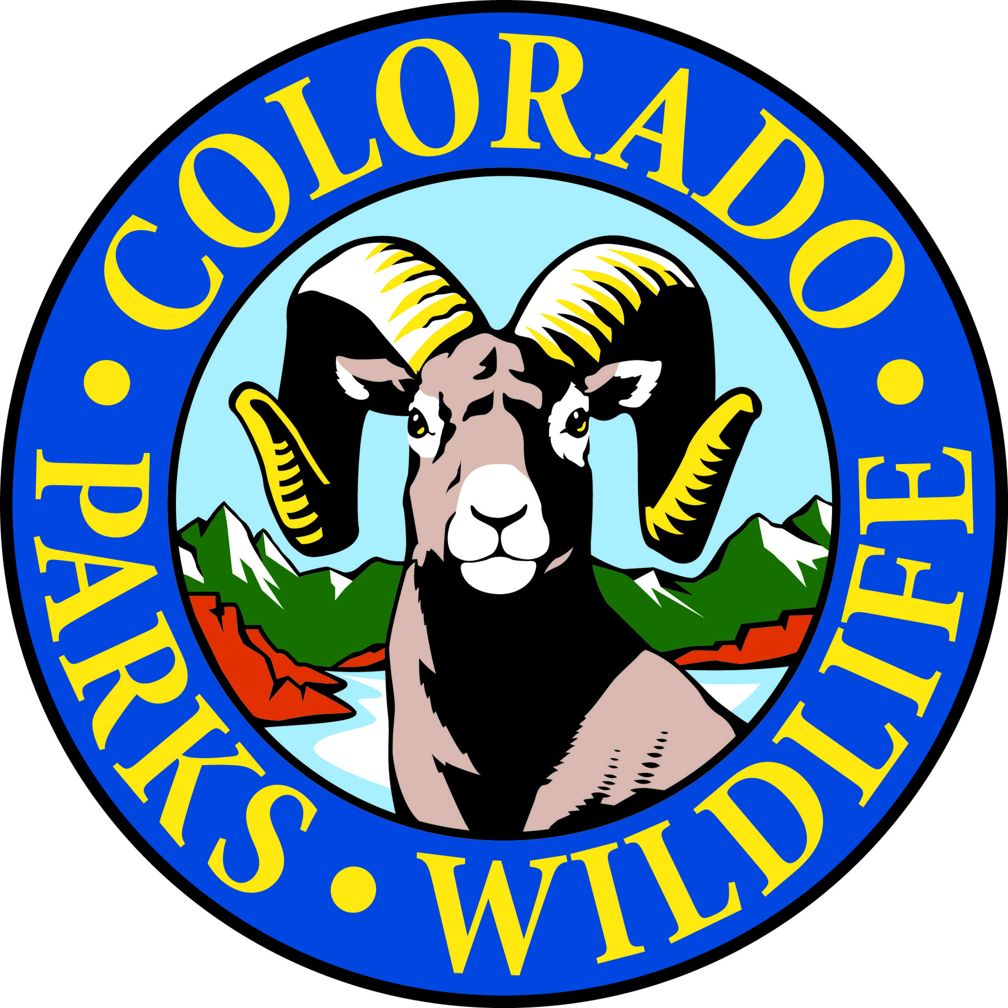

Cheyenne Mountain State Park is celebrating Colorado Day on August 3rd with Free Admission!

COLORADO SPRINGS, Colo. –Cheyenne Mountain State Park is located south of Colorado Springs at 410 JL Ranch Heights Road. Take Nevada Avenue south, which becomes Colorado State Highway 115 to JL Ranch Heights Road opposite the Main Gate One entrance to Fort Carson. Turn to the west to the park entrance. Programs are free unless otherwise noted, but vehicles entering the park must have a $7 daily or $70 annual State Parks pass. For more information, call 719-576-2016.

August Programs 2015

Every Wednesday and Saturday

Program: Yoga in the Park
Time: 9:00 a.m.
Location: Cheyenne Mountain State Park Visitor Center
Details: What better setting for a morning workout than Cheyenne Mountain State park. Join instructor Semwal for a yoga session every Wednesday and Saturday. Beginners welcome. Occasionally, classes are moved or cancelled.
Information: 719-576-2016, www.cpw.state.co.us

Saturday, August 1

Program: Junior Ranger Class – Fire Safety
Time: 1:00 p.m.
Location: Cheyenne Mountain State Park Camper Services Activity Room
Details: Do you have the right stuff to be a Junior Park Ranger? Find out about the good, the bad and the ugly of wildfires, and how rangers put out a wildfire. You can pick up a Junior Ranger training booklet at the Visitor Center or at class. Kids 7-12 years old can earn a Junior Ranger badge and/or a colorful patch depending on levels completed.
Information: 719-576-2016, www.cpw.state.co.us

Program: Bats are Beautiful
Time: 7:00 p.m.
Location: Cheyenne Mountain State Park Camper Services Activity Room
Details: Through horror movies and other misinformation bats have gotten a bad rap. Join us to separate fact from fantasy about these flying mammals. Learn how bats are an essential component of the ecosystem and why they deserve our protection.
Information: 719-576-2016, www.cpw.state.co.us

Monday, August 3

Program: Colorado Day Open House-Free Admission
Time: 10 a.m. to 1 p.m.
Location: Cheyenne Mountain State Park Visitor Center
Details: Come join us for a variety of nature and outdoor activities on this free admission day to the park. Learn about all the recreational opportunities at Cheyenne Mountain State and the plants and animals you can find here.
Information: 719-576-2016, www.cpw.state.co.us

Program: Colorado Family Mystery Hike
Time 1:00 p.m.
Location: Cheyenne Mountain State Park Visitor Center
Details: This naturalist-led hike challenges families to search for hidden clues along a one mile easy trail that will help you learn about Colorado animal and plants. Recommended for ages 4 years and up. Children must be accompanied by an adult.
Information: 719-576-2016, www.cpw.state.co.us

Wednesday, August 5

Program: Wildflower Wednesday Walk
Time: 9:00 a.m.
Location: Cheyenne Mountain State Park Visitor Center
Details: Bring your camera, water and a notepad and join volunteer park naturalists, Pat Cooper and Lucy Bell, on a one and a half hour nature hike to see what’s blooming in the park this week. Reservations required.
Information: 719-576-2016, www.cpw.state.co.us

Friday, August 7

Program: Fitness Hike
Time: 9:00 a.m.
Location: Cheyenne Mountain State Park Visitor Center
Details: If you’re interested in burning some calories on the trails and enjoying some great views, this is the place to be. Join us for your choice of beginning, intermediate or advanced hikes.
Information: 719-576-2016, www.cpw.state.co.us

Saturday, August 8

Program: Beginning Archery
Time: 10:00 a.m.
Location: Cheyenne Mountain State Park Archery Range
Details: Have you always wanted to shoot like the Arrow or Katniss? Here is a way to get started! One on one instruction will help students learn how to shoot. All equipment is provided. This class is for students 8 years old and up. Reservations are required and the class is limited to 12 students.
Information: 719-576-2016, www.cpw.state.co.us

Program: Archery Practice
Time: 1:00 p.m.
Location: Cheyenne Mountain State Park Archery Range
Details: For those who have completed our beginning archery class, we are offering a practice session to hone your skills. Equipment and instruction provided. Reservations required.
Information: 719-576-2016, www.cpw.state.co.us

Program: Animal Tracks
Time: 1:00 p.m.
Location: Cheyenne Mountain State Park Camper Services
Details: How can you tell the difference between a coyote track, a bobcat track, or a badger track? Come find out! You will receive a track guide and make a plaster track to take home.
Information: 719-576-2016, www.cpw.state.co.us

Program: Bears and Mountain Lions
Time: 7:00 p.m.
Location: Cheyenne Mountain State Park Prairie Falcon Amphitheater
Details: What do I do if I cross paths with a mountain lion or bear? Knowing about lion and bear behaviors can help to keep you and your family safe in the outdoors. Join us for an in-depth discussion of mountain lion and black bear biology.
Information: 719-576-2016, www.cpw.state.co.us

Sunday, August 9

Program: GPS and Geocaching
Time: 1:00 p.m.
Location: Cheyenne Mountain State Park Camper Services
Details: Park volunteers, Dan and Pam Scott help you learn about geocaching and the basic operation of a GPS unit. This one and a half hour program will let you apply your skills on a treasure hunt to locate geocaches hidden in the park. GPS units will be provided. For ages 8 and up. Reservations required.
Information: 719-576-2016, www.cpw.state.co.us

Saturday, August 15

Program: Beginning Archery
Time: 10:00 a.m.
Location: Cheyenne Mountain State Park Archery Range
Details: Have you always wanted to shoot like the Arrow or Katniss? Here is a way to get started! One on one instruction will help students learn how to shoot. All equipment is provided. This class is for students 8 years old and up. Reservations are required and the class is limited to 12 students.
Information: 719-576-2016, www.cpw.state.co.us

Program: Archery Practice
Time: 1:00 p.m.
Location: Cheyenne Mountain State Park Archery Range
Details: For those who have completed our beginning archery class, we are offering a practice session to hone your skills. Equipment and instruction provided. Reservations required.
Information: 719-576-2016, www.cpw.state.co.us

Program: Junior Ranger – Wildlife Encounters
Time: 1:00 p.m.
Location: Cheyenne Mountain State Park Camper Services Activity Room
Details: Do you have the right stuff to be a Junior Park Ranger? What does a ranger do when she encounters a potentially dangerous wild animal? Come find out! You can pick up a Junior Ranger training booklet at the Visitor Center or at class. Kids 7-12 years old can earn a Junior Ranger badge and/or a colorful patch depending on levels completed.
Information: 719-576-2016, www.cpw.state.co.us

Program: Colorado Wildlife
Time: 7:00 p.m.
Location: Cheyenne Mountain State Park Amphitheater
Details: Come discover Colorado’s common animals. Observe skulls, tracks and skins which provide clues to how animals behave, what they eat and their extraordinary senses.
Information: 719-576-2016, www.cpw.state.co.us

Sunday, August 16

Program: Family Mystery Hike
Time 1:00 p.m.
Location: Cheyenne Mountain State Park Visitor Center
Details: This naturalist-led hike challenges families to solve a puzzle, riddle or mystery as they search for hidden clues along a one mile easy trail. We have eight different mystery hikes so come see which one needs to be solved today. Recommended for ages 4 years and up. Children must be accompanied by an adult.
Information: 719-576-2016, www.cpw.state.co.us

Wednesday, August 19

Program: Wildflower Wednesday Walk
Time: 9:00 a.m.
Location: Cheyenne Mountain State Park Visitor Center
Details: Bring your camera, water and a notepad and join volunteer park naturalists, Pat Cooper and Lucy Bell, on a one and a half hour nature hike to see what’s blooming in the park this week. Reservations required.
Information: 719-576-2016, www.cpw.state.co.us

Friday, August 21

Program: Fitness Hike
Time: 9:00 a.m.
Location: Cheyenne Mountain State Park Visitor Center
Details: If you’re interested in burning some calories on the trails and enjoying some great views, this is the place to be. Join us for your choice of beginning, intermediate or advanced hikes.
Information: 719-576-2016, www.cpw.state.co.us

Saturday, August 22

Program: Family Mystery Hike
Time: 10:00 a.m.
Location: Cheyenne Mountain State Park Visitor Center
Details: This naturalist-led hike challenges families to solve a puzzle, riddle or mystery as they search for hidden clues along a one mile easy trail. We have eight different mystery hikes so come see which one needs to be solved today. Recommended for ages 4 years and up. Children must be accompanied by an adult.
Information: 719-576-2016, www.cpw.state.co.us

Program: Owls
Time: 7:00 p.m.
Location: Cheyenne Mountain State Park Amphitheater
Details: We will explore the different kinds of owls that live here and how these birds are adapted to nighttime flying and hunting.
Information: 719-576-2016, www.cpw.state.co.us

Sunday, August 23

Program: Junior Ranger Class – Birds and Binoculars
Time: 1:00 p.m.
Location: Cheyenne Mountain State Park Camper Services
Details: Do you have the right stuff to be a Junior Park Ranger? Learn how to use binoculars and pick up tips on bird identification. Pick up a Junior Ranger training booklet at the Visitor Center or at class. Kids 7-12 years old can earn a Junior Ranger badge and/or a colorful patch depending on levels completed.
Information: 719-576-2016, www.cpw.state.co.us

Saturday, August 29

Program: Literary Walk in the Woods – John Muir by Jack Busher
Time: 1:00 p.m.
Location: Cheyenne Mountain State Park Visitor Center
Details: Last presented in 2013, Jack Busher is bringing back one of the most requested American nature writers, John Muir. Does Muir have connections to Colorado? Attend this presentation and find out. This program fills up so make a reservation early!
Information: 719-576-2016, www.cpw.state.co.us

Program: Full Moon Hike
Time: 7:30 p.m.
Location: Cheyenne Mountain State Park Visitor Center Parking Lot
Details: Join us on this one and a half hour guided evening stroll as we explore moonlit landscapes and discover the nocturnal activities of owls and other nighttime creatures. Bring a flashlight. Reservations requested.
Information: 719-576-2016, www.cpw.state.co.us

Sunday, August 30

Program: Discovery Hike
Time: 1:00 p.m.
Location: Cheyenne Mountain State Park Visitor Center.
Description: A naturalist leads this hike using binoculars, magnifying lenses and other tools. Along this one mile easy trail we find things big and small, close up and far away. Recommended for ages 4 years and up. Children must be accompanied by an adult.
Information: 719-576-2016, www.cpw.state.co.us

