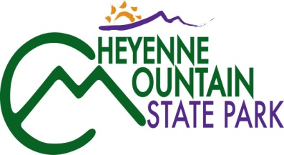
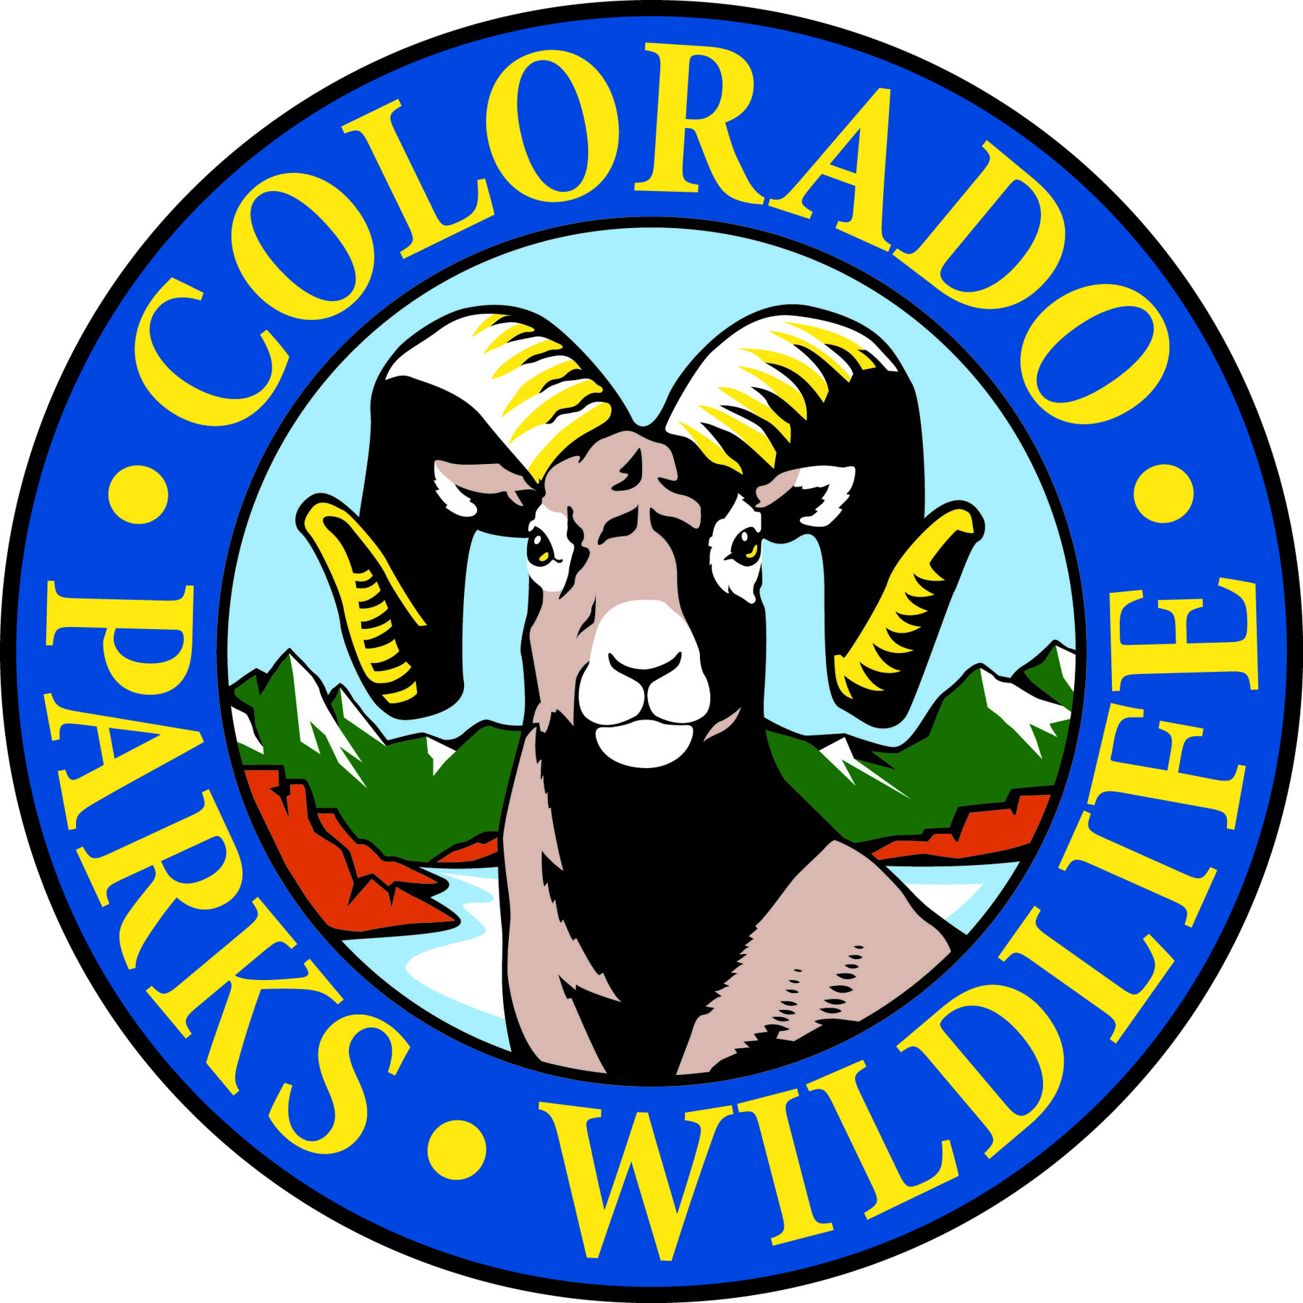

Cheyenne Mountain State Park is celebrating Colorado Day on August 4th!

COLORADO SPRINGS, Colo. –Cheyenne Mountain State Park is located south of Colorado Springs at 410 JL Ranch Heights Road. Take Nevada Ave. south which becomes Colorado State Highway 115 to JL Ranch Heights Road opposite the Main Gate One entrance to Fort Carson. Turn to the west to the park entrance. Programs are free but, unless otherwise noted, vehicles entering the park must have a $7 daily or $70 annual State Parks pass. For more information, call 719-576-2016.

August 2014
Every Wednesday and Saturday

Program: Yoga in the Park
Time: 9:00 a.m.
Location: Cheyenne Mountain State Park Visitor Center
Details: What better setting for a morning workout than Cheyenne Mountain State park. Join instructor Semwal for a yoga session every Wednesday and Saturday. Beginners welcome. Occasionally, classes are moved or cancelled.
Information: 719-576-2016; www.cpw.state.co.us

Saturday, August 2nd

Program: Hiking Through History
Time: 10 a.m.
Location: Cheyenne Mountain State Park Camper Services Activity Room
Details: Find out about the rich ranching heritage of Cheyenne Mountain on this historical hike led by park volunteers. Along the 1.5 mile route, hike leaders will show historical photos and point out former locations of the ranch house, barn and other buildings. Plan for being out about two hours. Reservations and a State Parks pass are required.
Information: 719-576-2016; www.cpw.state.co.us

Program: Junior Ranger – First Aid
Time: 1:00 p.m.
Location: Cheyenne Mountain State Park Camper Services Activity Room
Details: Do you have the right stuff to be a Junior Park Ranger? What does a ranger do when she encounters a potentially dangerous wild animal? Come find out! You can pick up a Junior Ranger training booklet at the Visitor Center or at class. Kids 7-12 years old can earn a Junior Ranger badge and/or a colorful patch depending on levels completed. Reservations requested. State Parks pass required.
Information: 719-576-2016; www.cpw.state.co.us

Program: Bears and Mountain Lions
Time: 7:00 p.m.
Location: Cheyenne Mountain State Park Amphitheater
Details: What do I do if I cross paths with a mountain lion or bear? Knowing about lion and bear behaviors can help to keep you and your family safe in the outdoors. Join us for an in-depth discussion of mountain lion and black bear biology. State Parks pass required.
Information: 719-576-2016; www.cpw.state.co.us

Sunday, August 3rd

Program: Mystery Hike
Time: 1:00 p.m.
Location: Cheyenne Mountain State Park Visitor Center
Details: This naturalist-led one and a half hour hike challenges families to solve a puzzle, riddle or mystery as they walk and search for hidden clues along a one mile, easy trail. Recommended for ages 4 years and up. Children must be accompanied by an adult. Reservation requested. State Parks pass required.
Information: 719-576-2016; www.cpw.state.co.us

Monday, August 4th

Program: Colorado Day Open House-Free Admission
Time: Noon to 4:00 p.m.
Location: Call Cheyenne Mountain State park for activity locations.
Details: Come join us for a variety of nature and outdoor activities on this free admission day to the park. Learn about all the recreational opportunities at Cheyenne Mountain State Park and discover scenic and wildlife viewing opportunities near Colorado Springs.
Information: 719-576-2016; www.cpw.state.co.us

Program: Colorado Jeopardy
Time: 7:00 p.m.
Location: Cheyenne Mountain State Park Amphitheater
Details: Join us for an active game of Jeopardy with categories challenging your knowledge of all things Colorado. State Parks pass required.
Information: 719-576-2016; www.cpw.state.co.us

Tuesday, August 5th

Program: MapMyFitness Hike
Time: 9:00 a.m.
Location: Cheyenne Mountain State Park Visitor Center.
Details: Remember that one invigorating hike with the great view? Now your Smartphone can help you record that great time! Burn calories and learn how to create an on-line hiking journal to track your progress with a popular app. One, two or three mile fitness hikes are offered. A Smartphone is not required to participate. Don’t forget to bring water and sturdy hiking shoes or boots. Reservations and a State Parks pass required.
Information: 719-576-2016; www.cpw.state.co.us

Thursday, August 7th

Program: Pre-School Nature Adventures - A Smelly Adventure
Time: 9:30 a.m.
Location: Cheyenne Mountain State Park Camper Services
Details: Three to five year-olds and their parents are invited to join us for a guided investigation of skunks and the sense of smell. Spend an hour exploring the life and behaviors of one of our smelly wildlife friends through interactive play, stories, puppets and a make-and-take craft. Reservations and a State Parks pass are required.
Information: 719-576-2016; www.cpw.state.co.us

Saturday, August 9th

Program: Junior Ranger – Map Skills
Time: 10:00 a.m.
Location: Cheyenne Mountain State Park Camper Services Activity Room
Details: Do you have the right stuff to be a Junior Park Ranger? Learn how rangers make maps in this one and a half hour program. Make your own map and then use it to find prizes. You can pick up a Junior Ranger training booklet at the Visitor Center or at class. Kids 7-12 years old can earn a Junior Ranger badge and/or a colorful patch depending on levels completed. Reservations requested. State Parks pass required.
Information: 719-576-2016; www.cpw.state.co.us

Program: Mystery Hike
Time: 1:00 p.m.
Location: Cheyenne Mountain State Park Visitor Center
Details: This naturalist-led one and a half hour hike challenges families to solve a puzzle, riddle or mystery as they walk and search for hidden clues along a one mile, easy trail. Recommended for ages 4 years and up. Children must be accompanied by an adult. Reservation requested. State Parks pass required.
Information: 719-576-2016; www.cpw.state.co.us

Program: Bats Are Our Buddies
Time: 8:30 p.m.
Location: Cheyenne Mountain State Park Amphitheater
Details: Through horror movies and other misinformation bats have gotten a bad rap. Join volunteer park naturalist, Debbie Ackley, as she separates fact from fantasy in this informative presentation on these flying mammals. Learn how bats are an essential component of the ecosystem and why they deserve our protection. State Park pass required.
Information: 719-576-2016; www.cpw.state.co.us

Sunday, August 10th

Program: Full Moon Hike
Time: 8:30 p.m.
Location: Cheyenne Mountain State Park Visitor Center
Details: Join us on this one and a half hour guided evening stroll as we explore moonlit landscapes and discover the nocturnal activities of owls and other nighttime creatures. Bring a flashlight. Reservations requested. State Park pass required.
Information: 719-576-2016; www.cpw.state.co.us

Tuesday, August 12th

Program: MapMyFitness Hike
Time: 9:00 a.m.
Location: Cheyenne Mountain State Park Visitor Center.
Details: Remember that one invigorating hike with the great view? Now your Smartphone can help you record that great time! Burn calories and learn how to create an on-line hiking journal to track your progress with a popular app. One, two or three mile fitness hikes are offered. A Smartphone is not required to participate. Don’t forget to bring water and sturdy hiking shoes or boots. Reservations and a State Parks pass required.
Information: 719-576-2016; www.cpw.state.co.us

Wednesday, August 13th

Program: Wildflower Wednesday Walk
Time: 9:00 a.m.
Location: Cheyenne Mountain State Park Visitor Center
Details: Bring your camera, water and a notepad and join volunteer park naturalists, Pat Cooper and Lucy Bell, on a one and a half hour nature hike to see what’s blooming in the park this week. Reservations and State Parks pass required.
Information: 719-576-2016; www.cpw.state.co.us

Saturday, August 16th

Program: Junior Ranger – Camping Rules and Regulations
Time: 10:00 a.m.
Location: Cheyenne Mountain State Park Camper Services Activity Room
Details: Do you have the right stuff to be a Junior Park Ranger? What does a ranger look for when patrolling campgrounds? Find out as you inspect one of our own campsites in this one and a half hour program. You can pick up a Junior Ranger training booklet at the Visitor Center or at class. Kids 7-12 years old can earn a Junior Ranger badge and/or a colorful patch depending on levels completed. Reservations requested. State Parks pass required.
Information: 719-576-2016; www.cpw.state.co.us

Program: Mystery Hike
Time: 1:00 p.m.
Location: Cheyenne Mountain State Park Visitor Center
Details: This naturalist-led one and a half hour hike challenges families to solve a puzzle, riddle or mystery as they walk and search for hidden clues along a one mile, easy trail. Recommended for ages 4 years and up. Children must be accompanied by an adult. Reservation requested. State Parks pass required.
Information: 719-576-2016; www.cpw.state.co.us

Program: Fire! The Good, Bad and Ugly
Time: 7:00 p.m.
Location: Cheyenne Mountain State Park Amphitheater
Details: Find out how wildfires can both hurt and help Colorado ecosystems and how fire mitigation can keep us safe. See some of the techniques and tools used for fighting wildfires. State Parks pass required.
Information: 719-576-2016; www.cpw.state.co.us

Sunday, August 17th

Program: A Literary Walk in the Woods with Robert Frost
Time: 1:00 p.m.
Location: Cheyenne Mountain State Park Visitor Center
Details: After a brief indoor discussion of Robert Frost, take a walk with volunteer Jack Busher to the rock garden on Zook Loop trail, where selected writings of the author will be read and discussed. Bring a portable camp chair or pad to sit on. Plan on two hours for this program. Book early as this fills up quickly. Reservations and a State Parks pass are required.
Information: 719-576-2016; www.cpw.state.co.us

Friday, August 19th

Program: MapMyFitness Hike
Time: 9:00 a.m.
Location: Cheyenne Mountain State Park Visitor Center.
Details: Remember that one invigorating hike with the great view? Now your Smartphone can help you record that great time! Burn calories and learn how to create an on-line hiking journal to track your progress with a popular app. One, two or three mile fitness hikes are offered. A smartphone is not required to participate. Don’t forget to bring water and sturdy hiking shoes or boots. Reservations and a State Parks pass required.
Information: 719-576-2016; www.cpw.state.co.us

Tuesday, August 22nd

Program: Hats, Chaps, Saddles and Ropes
Time: 7:00 p.m.
Location: Cheyenne Mountain State Park Amphitheater.
Details: Get the lowdown on cattle “wrangling” from retired rancher and cowboy, Dave Overlin, as he demonstrates the tools of the trade and explains the function of hats, chaps, and other cowboy attire. State Parks pass required.
Information: 719-576-2016; www.cpw.state.co.us

Saturday, August 23rd

Program: GPS and Geocaching
Time: 10:00 a.m.
Location: Cheyenne Mountain State Park Camper Services
Details: Park volunteers, Dan and Pam Scott help you learn about geocaching and the basic operation of a GPS unit. This one and a half hour program will let you apply your skills on a treasure hunt to locate geocaches hidden in the park. GPS units will be provided. For ages 8 and up. Reservations and State Parks pass required.
Information: 719-576-2016; www.cpw.state.co.us

Program: Junior Ranger – Wildlife Encounters
Time: 1:00 p.m.
Location: Cheyenne Mountain State Park Camper Services Activity Room
Details: Do you have the right stuff to be a Junior Park Ranger? What does a ranger do when she encounters a potentially dangerous wild animal? Come find out! You can pick up a Junior Ranger training booklet at the Visitor Center or at class. Kids 7-12 years old can earn a Junior Ranger badge and/or a colorful patch depending on levels completed. Reservations requested. State Parks pass required.
Information: 719-576-2016; www.cpw.state.co.us

Program: Snakes!
Time: 7:00 p.m.
Location: Cheyenne Mountain State Park Amphitheater
Details: Come discover a few new things about some of the different snakes that live at Cheyenne Mountain State Park. Find out how they live and perhaps visit with a live snake. State Parks pass required.
Information: 719-576-2016; www.cpw.state.co.us

Sunday, August 24th

Program: Almost No Moon Hike
Time: 8:30 p.m.
Location: Cheyenne Mountain State Park Visitor Center
Details: Hey night owls, here’s a twist on night-time hikes. Come join us for a nearly new moon hike. That’s right, there will be little moonlight to aid us on our trek through the forest to listen for animal sounds and explore dark landscapes. Bring a flashlight and sturdy hiking shoes and plan to be out about 2 hours. Not recommended for children under 6
Information: 719-576-2016; www.cpw.state.co.us

Tuesday, August 26th

Program: MapMyFitness Hike
Time: 9:00 a.m.
Location: Cheyenne Mountain State Park Visitor Center.
Details: Remember that one invigorating hike with the great view? Now your Smartphone can help you record that great time! Burn calories and learn how to create an on-line hiking journal to track your progress with a popular app. One, two or three mile fitness hikes are offered. A smartphone is not required to participate. Don’t forget to bring water and sturdy hiking shoes or boots. Reservations and a State Parks pass required.
Information: 719-576-2016; www.cpw.state.co.us

Wednesday, August 27th

Program: Wildflower Wednesday Walk
Time: 9:00 a.m.
Location: Cheyenne Mountain State Park Visitor Center
Details: Bring your camera, water and a notepad and join volunteer park naturalists, Pat Cooper and Lucy Bell, on a one and a half hour nature hike to see what’s blooming in the park this week. Reservations and State Parks pass required.
Information: 719-576-2016; www.cpw.state.co.us

Saturday, August 30th

Program: Junior Ranger Class – Fire Safety
Time: 10:00 a.m.
Location: Cheyenne Mountain State Park Camper Services Activity Room
Do you have the right stuff to be a Junior Park Ranger? Find out about the good, the bad and the ugly of wildfires, and how rangers put out a wildfire. You can pick up a Junior Ranger training booklet at the Visitor Center or at class. Kids 7-12 years old can earn a Junior Ranger badge and/or a colorful patch depending on levels completed. State Parks pass required.
Information: 719-576-2016; www.cpw.state.co.us

Program: Family Mystery Hike
Time: 1:00 p.m.
Location: Cheyenne Mountain State Park Visitor Center
Details: This one and a half hour naturalist-led hike challenges families to solve a puzzle, riddle or mystery as they walk and search for hidden clues along a one mile, easy trail. Recommended for ages 4 years and up. Children must be accompanied by an adult. Reservations and a State Parks pass are required.
Information: 719-576-2016; www.cpw.state.co.us

Program: Big Cats!
Time: 7:00 p.m.
Location: Cheyenne Mountain State Park Amphitheater
Details: Colorado is home to three species of wild cats. Come join a park naturalist to find out about how to identify them, where they live and what they eat. State Parks pass required.
Information: 719-576-2016; www.cpw.state.co.us

Sunday, August 31st

Program: Outdoor Games!
Time: 1:00 p.m.
Location: Cheyenne Mountain State Park Amphitheater
Details: Come fish for pretend bass, play horseshoes, and toss beanbags into the holes! These games are lots of fun for everyone!
Information: 719-576-2016; www.cpw.state.co.us

