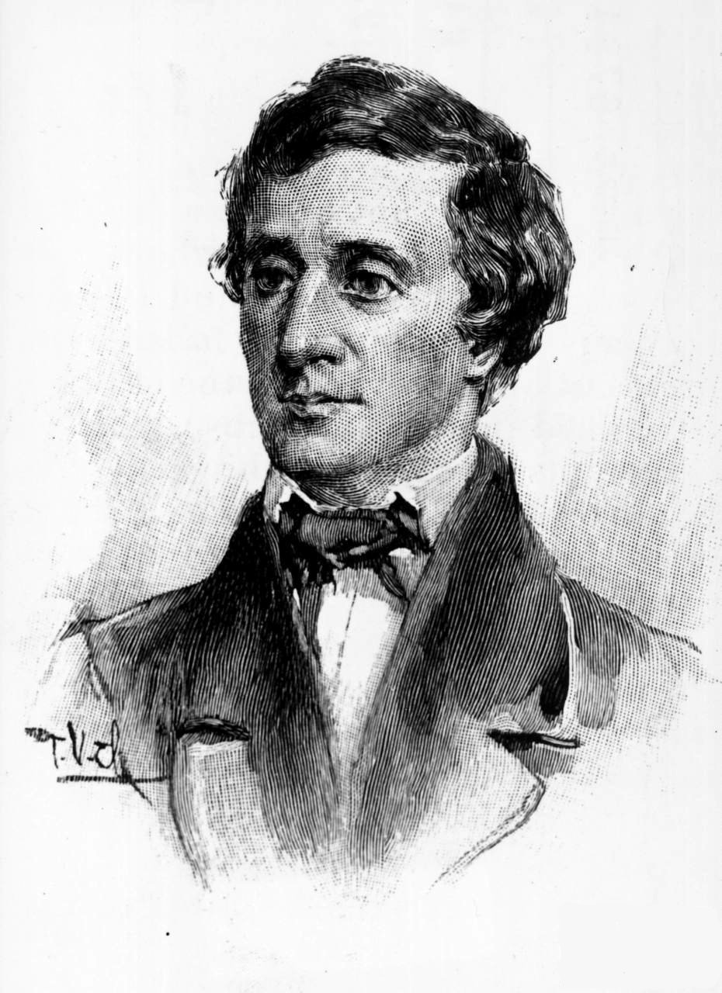
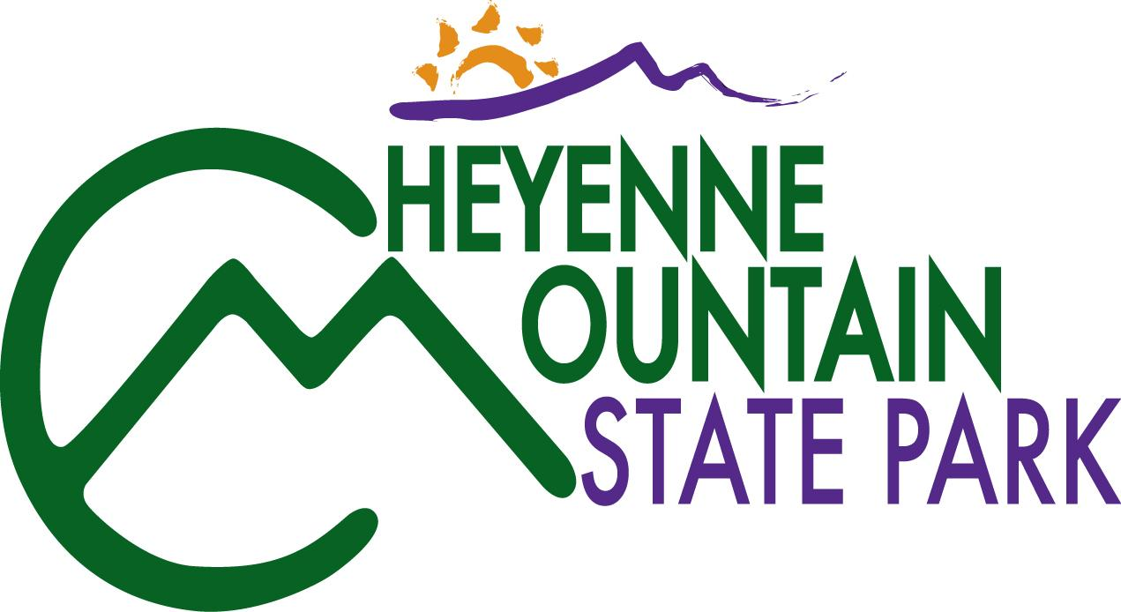
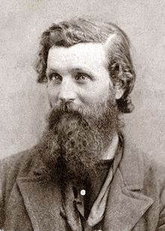

Presents
A Walk in the Woods with . . .

Experience some of the greatest nature writers of all time by reading excerpts of their work in the outdoors.
Program begins at the Visitor Center, as volunteer naturalists introduce each author and discuss their contributions.
Participants receive a sample of the author’s work before hiking to the Rock Garden area of Zook Trail Loop. Under the shade of ponderosa pine trees, selections of each author will be read and discussed.
Hiking distance: one mile round trip
Time: 1 PM to 3 PM
Cost: Class is free. Annual ($70) or Daily ($7) State Parks pass required on all vehicles.
Optional:
For your comfort, consider bringing a packable, light-weight folding chair
Reservations at 719 576-2016
Topic and Date:
May 19: Henry David Thoreau
June 9: John Muir
Directions:
Park address is 410 JL Ranch Heights, 80926.
It is located a few miles south of Colorado Springs off State Highway 115, directly across from Gate one entrance into Fort Carson
July 21: Ann Zwinger
August 18: Ann Zwinger repeat
September 22: Mary Oliver
October 20: Edward Abbey
The 2014 (April-October) season of "A Walk in the Woods" will feature nature writers chosen from the following list:
Robert Frost, Ralph Waldo Emerson, Aldo Leopold, Annie Dillard, Wendell Barry, Enos Mills, Rachel Carson, Loren Eisley, Emily Dickinson, Walt Whitman, E.O. Wilson, Frank Waters, Mary Austin and more.

