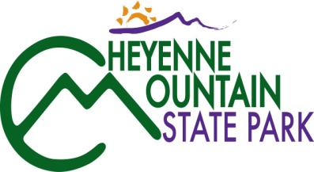
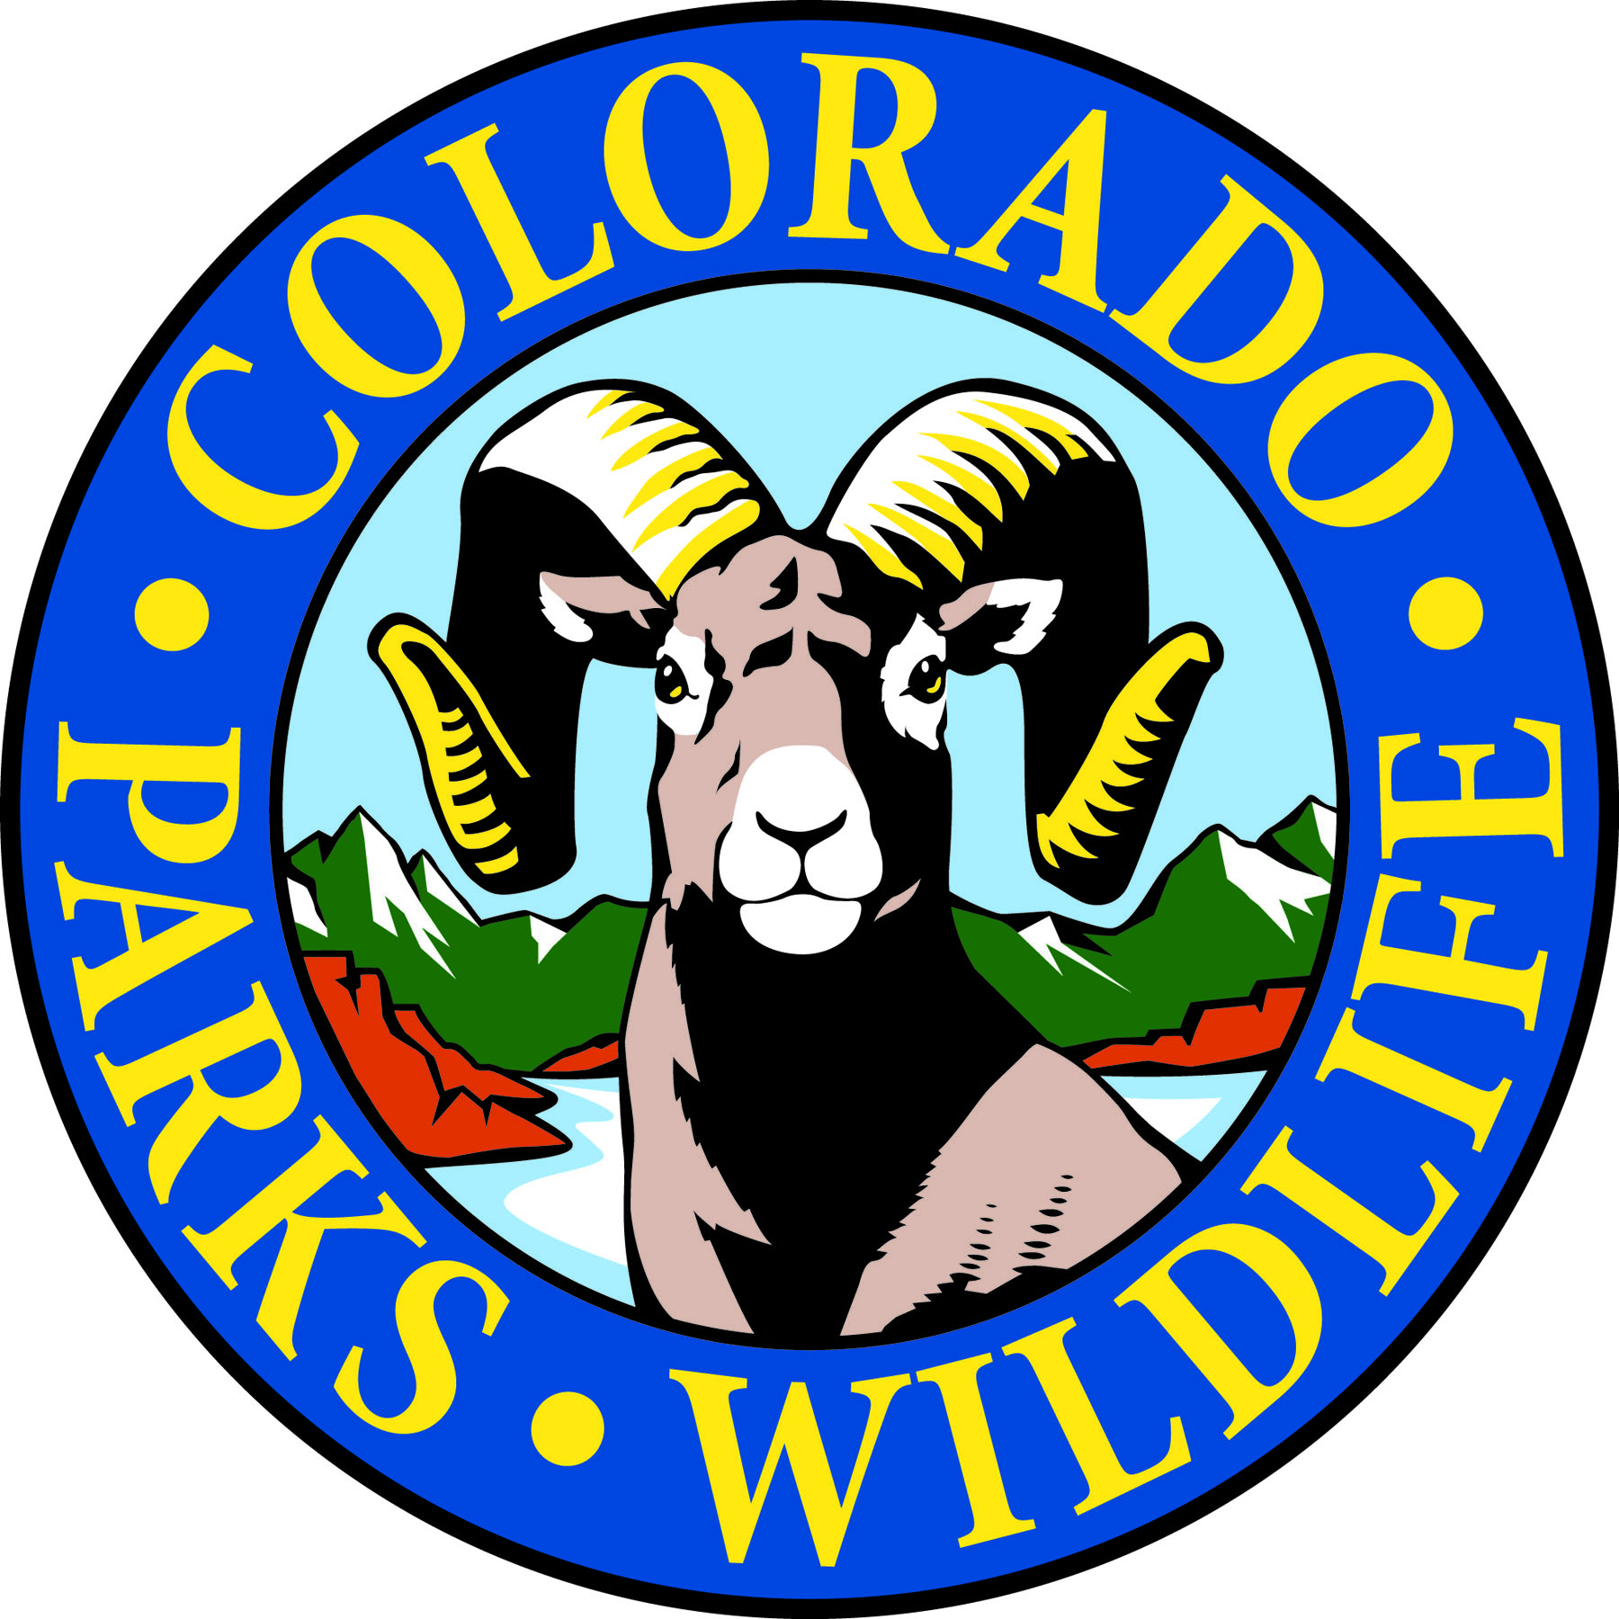

Cheyenne Mountain State Park July programs celebrate our national and natural heritage!

COLORADO SPRINGS, Colo. –Come to Cheyenne Mountain State Park to celebrate our nation’s birth a day early, on July 3rd, and play games, hear some music and watch the fireworks from Fort Carson! Cheyenne Mountain State Park is located south of Colorado Springs at 410 JL Ranch Heights Road. Take Nevada Ave. south which becomes Colorado State Highway 115 to JL Ranch Heights Road opposite the Main Gate One entrance to Fort Carson. Turn to the west to the park entrance. Programs are free but, unless otherwise noted, vehicles entering the park must have a $7 daily or $70 annual State Parks pass. For more information, call 719 576-2016.

July 2013
Pre-school Trail Adventures
9:30-10:45, Tuesday, July 2, check at Visitor Center for location.
3-5 year olds and their parents are invited to join volunteer park naturalist Jerri DeCarolis on a guided discovery hike along park trails. Dress for an all outdoor excursion. Reservations required. Call 719 576-2016. Parks pass required.

Wildflower Wednesday Walk
9-10:30 a.m., Wednesday, July 3 at the Visitor Center.
Bring your camera, water and a notepad and join volunteer park naturalists, Pat Cooper and Lucy Bell, on a nature hike to see what’s blooming in the park this week. Reservations required. Call 719 576-2016. Parks pass required.

Pre-Independence Day Celebration!
3-9:30 p.m., Wednesday, July 3 at the Amphitheater.
Come celebrate Independence Day a day early at Cheyenne Mountain State Park! From 3:00 to 6:00 p.m. come play games, make crafts, touch wildlife exhibits and more. Enjoy live music from 6:00 to 8:00 p.m. After that we will wait for the Fort Carson Fireworks by holding a trivia contest on U.S. and Colorado history as well as nature topics. For further information call 719 576-2016. Parks pass required

Square Dancing with the Rangers
7-8:30 p.m., Friday July 5 at Prairie Skipper Group Picnic Pavilion
Join us for some good old fashioned, foot-stompin’ fun. Lessons will be provided, so come and learn to square dance with the Cheyenne Mountain Rangers. For further information call 719 576-2016. Parks pass required.

Junior Ranger Class – Birds and Binoculars
10:00-11:30 a.m., Saturday, July 6 at Camper Services.
Do you have the right stuff to be a Junior Park Ranger? Get a head start by picking up a Junior Ranger training booklet at the Visitor Center or at class time. 7-12 year-olds can earn a Junior Ranger badge and/or colorful patch depending on levels completed. For reservations call 719 576-2016. Parks pass required.

Great Migration Challenge
1-2 p.m., Saturday, July 6 at Camper Services.
Experience the challenges and obstacles that birds encounter when they migrate by taking the great migration challenge. To make it to your destination you must take advantage of tail winds and avoid being eaten by a predator. Fun for all ages. For reservations call 719 576-2016. Parks pass required.

Cowboy Jokes and Poetry
7-8 p.m., Saturday, July 6 at the Amphitheater.
Join Cowpie Patty and Road Apple Jack for an evening of family fun as they share western slang, good old-fashioned, clean jokes and cowboy philosophies and witty sayings. . For further information call 719 576-2016. Parks pass required.

Family Mystery Hike
1-2:30 p.m., Sunday, July 7 at the Visitor Center.
This naturalist-led hike challenges families to solve a puzzle, riddle or mystery as they walk and search for hidden clues along a one mile, easy trail. Recommended for ages 4 years and up. Children must be accompanied by an adult. For reservations call 719 576-2016. Parks pass required.

Pre-school Trail Adventures
9:30-10:45, Tuesday, July 9, check at Visitor Center for location.
3-5 year olds and their parents are invited to join volunteer park naturalist Jerri DeCarolis on a guided discovery hike along park trails. Dress for an all outdoor excursion. Reservations required. Call 719 576-2016. Parks pass required.

The Truth about Rattlesnakes
7-8 p.m., Friday, July 12 at the Amphitheater.
Volunteer park naturalist, Barry Cooper, gives us the straight scoop on rattlesnakes as he shares his experiences growing up on a ranch. For further information call 719 576-2016. Parks pass required.

Family Mystery Hike
10-11:30 a.m., Saturday, July 13 at the Visitor Center.
This naturalist-led hike challenges families to solve a puzzle, riddle or mystery as they walk and search for hidden clues along a one mile, easy trail. Recommended for ages 4 years and up. Children must be accompanied by an adult. For further information call 719 576-2016. Parks pass required.

Junior Ranger Class – Map Reading
1 to 2:30 p.m., Saturday, July 13 at Camper Services.
This new program challenges young rangers, 7-12 years, to find their way by using a map to navigate to different locations in the park. At each location, junior rangers will encounter a simple challenge that must be completed. You can earn a Junior Ranger badge and colorful patch depending on levels completed. For further information call 719 576-2016. Parks pass required.

Who Hoots For You!
7-8 p.m., Saturday, July 13 at the Amphitheater.
Learn about Colorado’s owls from raptor expert and park volunteer, Debbie Barnes. Explore how they live, what they eat and some of the mysteries that make them so interesting. For further information call 719 576-2016. Parks pass required.

GPS and Geocaching
2:30-4 p.m., Sunday, July 14 at Camper Services.
Come learn the basic operation of a GPS unit. Then have fun using your skills to go on a treasure hunt to locate geocaches hidden in the park. GPS units will be provided. For ages 8 and up. For further information call 719 576-2016. Parks pass required.

Wildflower Wednesday Walk
9-10:30 a.m., Wednesday, July 17 at the Visitor Center.
Bring your camera, water and a notepad and join volunteer park naturalists, Pat Cooper and Lucy Bell, on a nature hike to see what’s blooming in the park this week. Reservations required. Call 719 576-2016. Parks pass required.

Plants: Pretty and Prickly
7-8 p.m., Friday, July 19 at the Amphitheater.
Discover a world of color in Colorado’s native plants. Many have unusual adaptations to our dry environment. Some we use in surprising ways, medicinal and otherwise. Botanists and park volunteers, Pat Cooper and Susan Simmons show us some of these wonderful plants. For further information call 719 576-2016. Parks pass required.

Cheyenne Mountain Young Birders Club
8-10 a.m., Saturday, July 20 at Camper Services.
Kids, 10 years and up, are invited to join Matt Skinner, college intern and park volunteer, as he continues the Cheyenne Mountain’s Young Birder Series. Learn to identify birds, discover fun bird facts, and make observations on a bird walk. Children 12 and under must be accompanied by an adult. Reservations required. Call 719 576-2016. Parks pass required.

Junior Ranger Class – First Aid
1-2:30 p.m., Saturday, July 20 at Camper Services.
Do you have the right stuff to be a Junior Park Ranger? Get a head start by picking up a Junior Ranger training booklet at the Visitor Center or one at class time. 7-12 year-olds can earn a Junior Ranger badge and/or colorful patch depending on levels completed. For further information call 719 576-2016. Parks pass required.

Colorado Wildlife
7-8 p.m., Saturday, July 20 at the Amphitheater.
Wildlife biologist, Roger Peyton from Fort Carson will display a variety of taxidermy mounts of Colorado wildlife as he shares important information about the behaviors of each animal and what to do if you have an encounter with one. For all ages. . For further information call 719 576-2016. Parks pass required.

A Walk in the Woods with Ann Zwinger
1-3 p.m., Sunday, July 21 at the Visitor Center.
Come walk with a volunteer naturalist on the Zook Trail. At the Rock Garden relax under the trees as selections from Ann Zwinger’s writings are read and discussed. Reservations required. Call 719 576-2016. Parks pass required.

Full Moon Hike
8-9:30 p.m., Monday, July 22 at Camper Services.
Join us on this guided evening stroll as we explore moonlit landscapes and discover the nocturnal activities of owls and other nighttime creatures. Bring a flashlight. For further information call 719 576-2016. Parks pass required.

A Rear View of Insects
7-8 p.m., Friday, July 26 at the Amphitheater.
The backend of insects are supplied with many special structures for reproduction, stinging, egg-laying and more. Come explore these unique adaptations and find out how they help insects. Fun for all ages. For further information call 719 576-2016. Parks pass required

Family Mystery Hike
10-11:30 a.m., Saturday, July 27 at the Visitor Center.
This naturalist-led hike challenges families to solve a puzzle, riddle or mystery as they walk and search for hidden clues along a one mile, easy trail. Recommended for ages 4 years and up. Children must be accompanied by an adult. For further information call 719 576-2016. Parks pass required.

Junior Ranger Class – Rules and Regulations
1 to 2:30 p.m., Saturday, July 27 at Camper Services.
Do you have the right stuff to be a Junior Park Ranger? Get a head start by picking up a Junior Ranger training booklet at the Visitor Center or one at class time. 7-12 year-olds can earn a Junior Ranger badge and/or colorful patch depending on levels completed. For further information call 719 576-2016. Parks pass required.

Elk and Deer Have a Lot on Their Minds
7-8 p.m., Saturday, July 27 at Camper Services.
Can you tell the difference between elk, mule deer, and white-tailed deer antlers? Join Senior Park Ranger, Stacey, as she investigates the form and function of antlers and why they are important to animals of the deer family. For further information call 719 576-2016. Parks pass required.

Wildflower Wednesday Walk
9-10:30 a.m., Wednesday, July 31 at the Visitor Center.
Bring your camera, water and a notepad and join volunteer park naturalists, Pat Cooper and Lucy Bell, on a nature hike to see what’s blooming in the park this week. Reservations required. Call 719 576-2016. Parks pass required.

