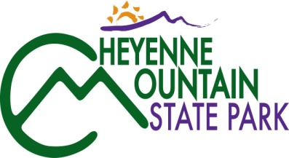
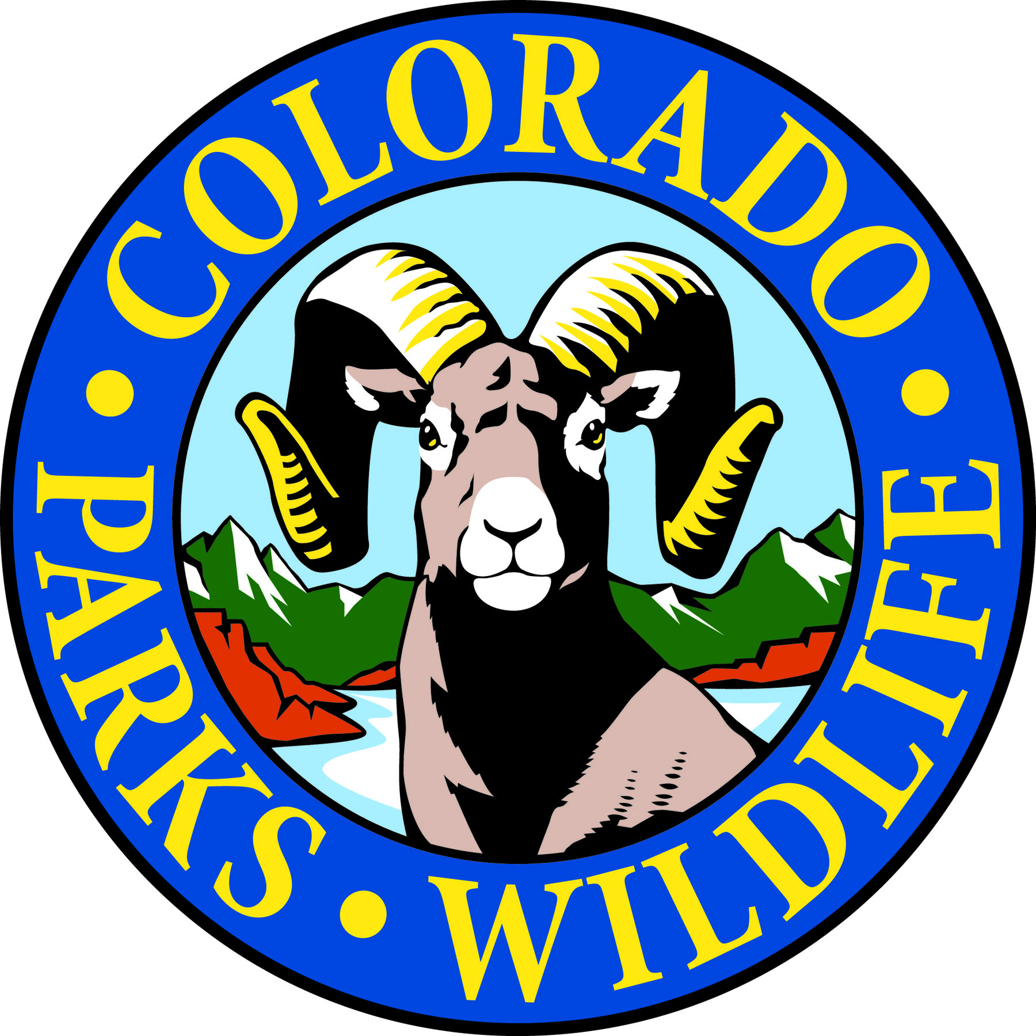

Cheyenne Mountain State Park August Programs are full of discovery!

COLORADO SPRINGS, Colo. –Two special workshops are scheduled at Cheyenne Mountain State Park. The first provides an in-depth understanding of Colorado’s native spiders. The second is a fascinating exploration of the local geologic history. Cheyenne Mountain State Park is located south of Colorado Springs at 410 JL Ranch Heights Road. Take Nevada Ave. south which becomes Colorado State Highway 115 to JL Ranch Heights Road opposite the Main Gate One entrance to Fort Carson. Turn to the west to the park entrance. Programs are free but, unless otherwise noted, vehicles entering the park must have a $7 daily or $70 annual State Parks pass. For more information, call 719 576-2016.

August 2013
Pre-school Trail Adventures
9:30-10:45, Thursday, August 1, check at Visitor Center for location.
3-5 year olds and their parents are invited to join volunteer park naturalist Jerri DeCarolis on a guided discovery hike along park trails. Dress for an all outdoor excursion. Reservations required. Call 719 576-2016. Parks pass required.

Hats, Chaps, and Spurs
7:00-8:00 p.m., Friday, August 2 at the Amphitheater.
Come find out what ranching is really like from park volunteer and rancher, David Overlin. He will bring all kinds of ranching equipment and demonstrate how each piece is used. For further information call 719 576-2016. Parks pass required.

Junior Ranger Class – Wildlife Encounters
10:00-11:30 a.m., Saturday, August 3 at Camper Services.
Do you have the right stuff to be a Junior Park Ranger? Get a head start by picking up a Junior Ranger training booklet at the Visitor Center or at class time. 7-12 year-olds can earn a Junior Ranger badge and/or colorful patch depending on levels completed. For reservations call 719 576-2016. Parks pass required.

Bob the Cat Puppet Show
1:00-2:00 p.m., Saturday, August 3 at Camper Services.
Meet Bob the Cat as he introduces us to all his Cheyenne Mountain friends and explores the many habitats and hiding place for park wildlife. For further information call 719 576-2016. Parks pass required.

Cheyenne Mountain Young Birders Club
2:30-4:30 p.m., Saturday, August 3 at Camper Services.
Kids, 10 years and up, are invited to join Matt Skinner, college intern and park volunteer, as he continues the Cheyenne Mountain’s Young Birder Series. Learn to identify birds, discover fun bird facts, and make observations on a bird walk. Children 12 and under must be accompanied by an adult. Reservations required. Call 719 576-2016. Parks pass required.

The Zebulon Pike Expedition
7-8 p.m., Saturday, August 3 at Camper Services.
Volunteer park naturalist, Lee Tatum, recounts Zebulon Pike’s unsuccessful ascent of Pike’s Peak. Pike’s exploration of Colorado provides intrigue, mystery, and controversy. After hearing the whole story, judge for yourself whether Pike was a spy for the U.S. military or just an adventurous explorer. For all ages. Reservations at (719) 576-2016. Meet at the Camper Services.

Family Mystery Hike
1-2:30 p.m., Sunday, August 4 at the Visitor Center.
This naturalist-led hike challenges families to solve a puzzle, riddle or mystery as they walk and search for hidden clues along a one mile, easy trail. Recommended for ages 4 years and up. Children must be accompanied by an adult. For reservations call 719 576-2016. Parks pass required.

Ant Antics
9:30-10:45, Thursday, August 8 at the Visitor Center.
3-5 year olds and their parents are invited to join volunteer park naturalist Jerri DeCarolis to learn about ants through guided discovery and a trail walk. Reservations required. Call 719 576-2016. Parks pass required.

Bats are Beautiful
7-8 p.m., Saturday, August 9 at the Amphitheater.
Bats have been given a bad reputation through movies and folklore. Volunteer park naturalist, Barry Cooper, gives us the straight scoop on bats as he shares how important bats are to us all. For further information call 719 576-2016. Parks pass required.

GPS and Geocaching
10:30-noon, Saturday, August 10 at Camper Services.
Come learn the basic operation of a GPS unit. Then have fun using your skills to go on a treasure hunt to locate geocaches hidden in the park. GPS units will be provided. For ages 8 and up. For further information call 719 576-2016. Parks pass required.

Spider Identification Workshop
1:00-5:00 p.m., Saturday, August 10 at Camper Services.
Cheyenne Mountain State Park is proud to sponsor a half day spider workshop conducted by Dr. Paula Cushing from the Denver Museum of Nature and Science. Dr. Cushing will cover spider biology and behavior and conduct field work to locate and collect spiders for research. Recommended for adults and older teens. Cost for the workshop is $5 to cover printing of the Spider Handbook. Space is limited and pre-registration is required. Deadline for all registrations is August 5. To sign up, call the park visitor center at 719 576-2016. Parks pass required.

Getting Face to Face with Wildlife
7-7:45 p.m., Saturday, August 10 at Camper Services.
Did you know that the best time of day to look for animals is early in the morning or late in the evening? Or why most animals are afraid of a person wearing sunglasses? Learn the techniques the pros use, such as how to look and where to look, when looking for and watching animals in Colorado. Topics include how to enjoy wildlife safely and responsibly. For further information call 719 576-2016. Parks pass required.

Lex Nichols Concert
7:45-8:45 p.m., Saturday August 10 at the Amphitheater.
Lex will be playing Native American flute and guitar music. He has been featured on Echoes radio, National Public Radio and Native Radio.com. Settle back and enjoy this talented performer. For further information call 719 576-2016. Parks pass required.

Wildflower Wednesday Walk
9-10:30 a.m., Wednesday, August 14 at the Visitor Center.
Bring your camera, water and a notepad and join volunteer park naturalists, Pat Cooper and Lucy Bell, on a nature hike to see what’s blooming in the park this week. Reservations required. Call 719 576-2016. Parks pass required.

Rocks are Moving!
8:00-noon, Saturday, August 17 at Camper Services.
This workshop will begin with an introduction to the geologic history of Cheyenne Mountain State Park. Then geologist and park volunteer, Dick Standart, will lead a hike to some of the unique features that can be seen in the park. Be prepared for a hike of 3-5 miles and come dressed for the weather and carry water. Space is limited and pre-registration is required. Deadline for all registrations is August 12. Call 719 576-2016. Parks pass required.

Junior Ranger Class – Fire Safety
1-2:30 p.m., Saturday, August 17 at Camper Services.
Do you have the right stuff to be a Junior Park Ranger? Get a head start by picking up a Junior Ranger training booklet at the Visitor Center or one at class time. 7-12 year-olds can earn a Junior Ranger badge and/or colorful patch depending on levels completed. For further information call 719 576-2016. Parks pass required.

Raptors
7-8 p.m., Saturday, August 17 at the Camper Services.
Park volunteer and birding expert, Debbie Barnes will share her photographs and knowledge of hawks and eagles that can be found in Cheyenne Mountain State Park. For further information call 719 576-2016. Parks pass required.

A Walk in the Woods with Robert Frost
1-3 p.m., Sunday, August 18 at the Visitor Center.
Come walk with a volunteer naturalist on the Zook Trail. At the Rock Garden relax under the trees as selections from Robert Frost’s writings are read and discussed. Reservations required. Call 719 576-2016. Parks pass required.

Full Moon Hike
8-9:30 p.m., Tuesday, August 20 at Camper Services.
Join us on this guided evening stroll as we explore moonlit landscapes and discover the nocturnal activities of owls and other nighttime creatures. Bring a flashlight. For further information call 719 576-2016. Parks pass required.

Junior Ranger Class – Birds and Binoculars
10:00-11:30 a.m., Saturday, August 24 at Camper Services.
Do you have the right stuff to be a Junior Park Ranger? Get a head start by picking up a Junior Ranger training booklet at the Visitor Center or one at class time. 7-12 year-olds can earn a Junior Ranger badge and/or colorful patch depending on levels completed. For further information call 719 576-2016. Parks pass required.

Nature Crafts
1-2:30 p.m. Saturday, August 24 at Camper Services.
Come make some nature inspired crafts using natural materials. You can sculpture with clay made from sand and create pictures using seeds, rocks and plants. For further information call 719 576-2016. Parks pass required.

Snakes!
7-8 p.m., Saturday, August 24 at the Amphitheater.
Come discover a few new things about some of the different snakes that live at Cheyenne Mountain State Park. Find out how they live and how to tell them apart. For further information call 719 576-2016. Parks pass required.

Family Mystery Hike
1:00-2:30 p.m., Sunday, August 25 at the Visitor Center.
This naturalist-led hike challenges families to solve a puzzle, riddle or mystery as they walk and search for hidden clues along a one mile, easy trail. Recommended for ages 4 years and up. Children must be accompanied by an adult. For further information call 719 576-2016. Parks pass required.

Wildflower Wednesday Walk
9-10:30 a.m., Wednesday, August 28 at the Visitor Center.
Bring your camera, water and a notepad and join volunteer park naturalists, Pat Cooper and Lucy Bell, on a nature hike to see what’s blooming in the park this week. Reservations required. Call 719 576-2016. Parks pass required.

How Animals Prepare for Winter
7-8 p.m., Friday, August 30 at the Amphitheater.
Winter brings with it a variety of challenges for survival for Colorado wildlife. Discover the different ways animals adapt to the cold and scarcity of food. For further information call 719 576-2016. Parks pass required.

Family Mystery Hike
10-11:30 a.m., Saturday, August 31 at the Visitor Center.
This naturalist-led hike challenges families to solve a puzzle, riddle or mystery as they walk and search for hidden clues along a one mile, easy trail. Recommended for ages 4 years and up. Children must be accompanied by an adult. For further information call 719 576-2016. Parks pass required.

Junior Ranger Class – First Aid
1:00-2:30 p.m., Saturday, August 31 at Camper Services.
Do you have the right stuff to be a Junior Park Ranger? Get a head start by picking up a Junior Ranger training booklet at the Visitor Center or one at class time. 7-12 year-olds can earn a Junior Ranger badge and/or colorful patch depending on levels completed. For further information call 719 576-2016. Parks pass required.

Bear Aware
7:00-8:00 p.m., August 31 at the Amphitheater.
Ranger Jenny Ives will tell you about bear behavior and how to avoid bear encounters. She will also give you a few tips on how to deal with a bear to keep you and the bear safe if you do encounter one. For further information call 719 576-2016. Parks pass required.

